|  |  |
| --- | --- |
| Lab site editing Manual  Dr. Aaron Putzke | Jason Pinales, Colin Colby, Chase Lake, Andrew McNeil  CS 472 Software Engineering |

**Table of Content**

**Edit Home Page … Page 1**

**Edit Research Page(s) … Page 4**

**Edit About Page … Page 9**

**Edit Resources Page … Page 14**

**Edit General News/Grants Page … Page 17**

**Edit Publications Page … Page 24**

**Edit Lab Members’ Page … Page 25**

**Home: Swapping Pictures**

* **Open “index.html” with text editing software**

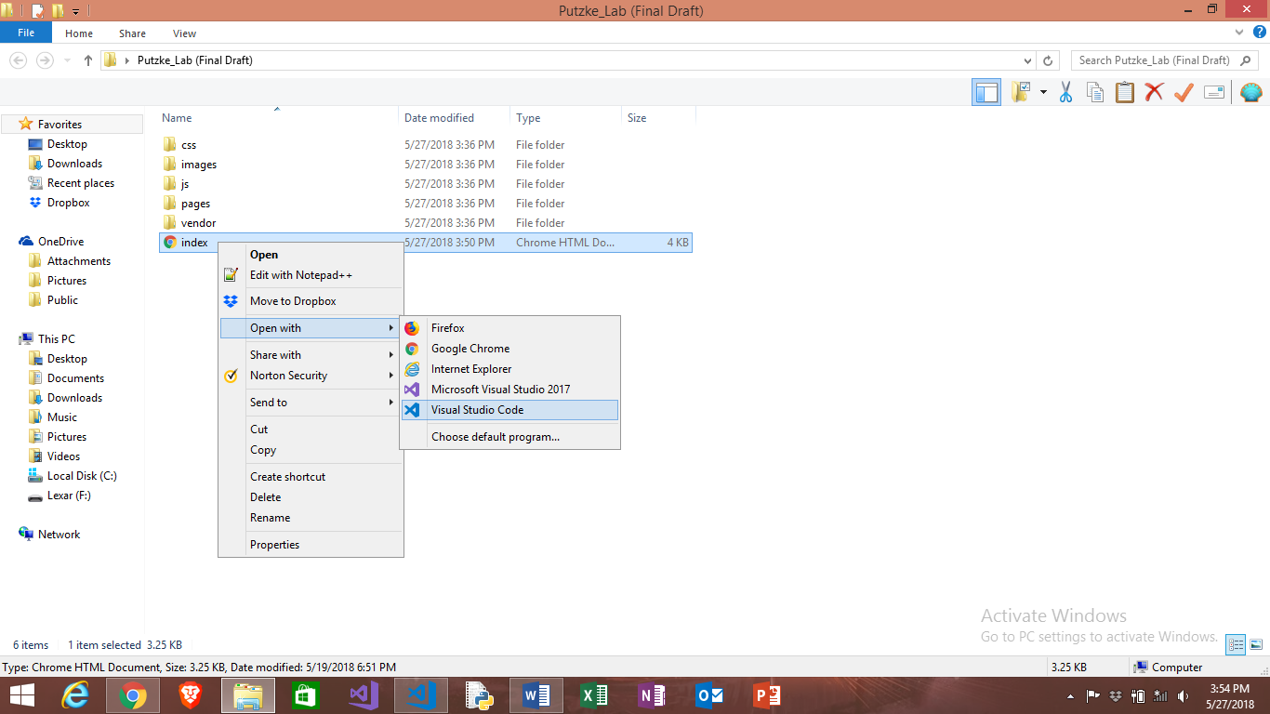

* **Find image name of desired image in “…/images/Home”**

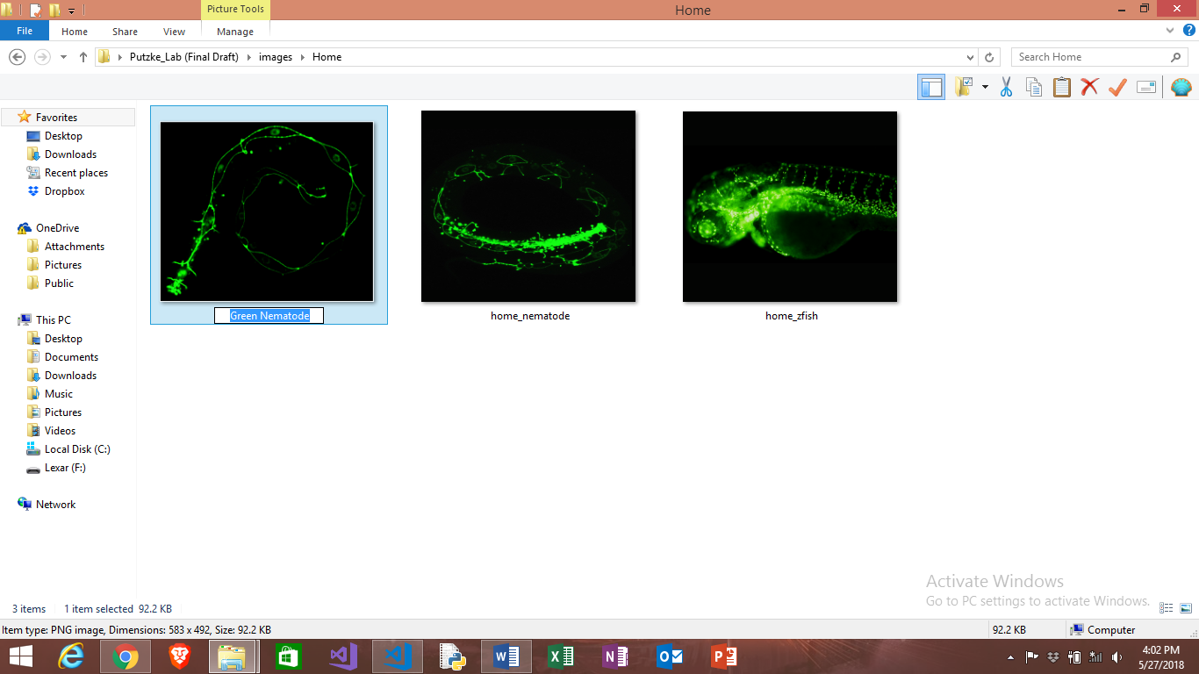

* **Change name of image title to desired picture from folder**

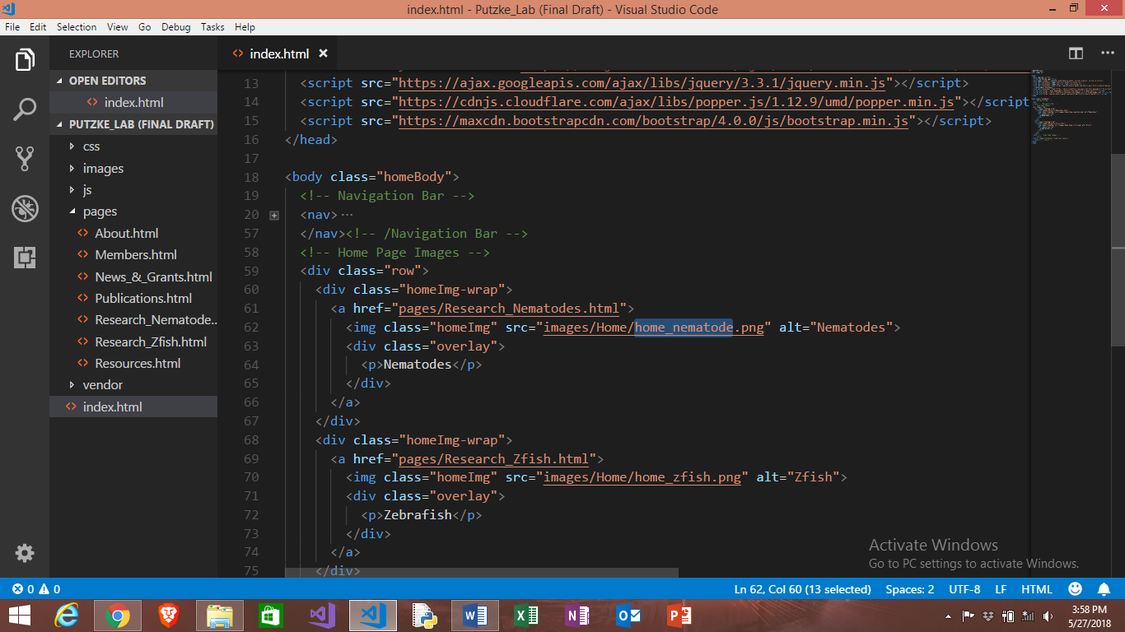

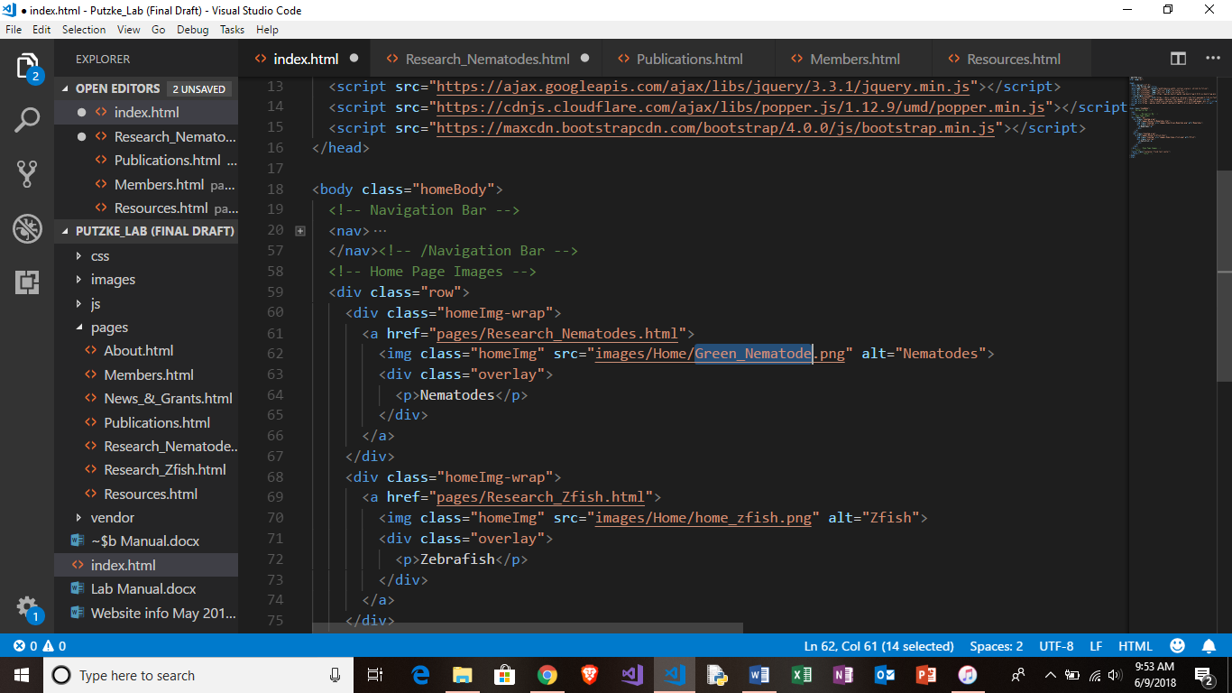

**Before**

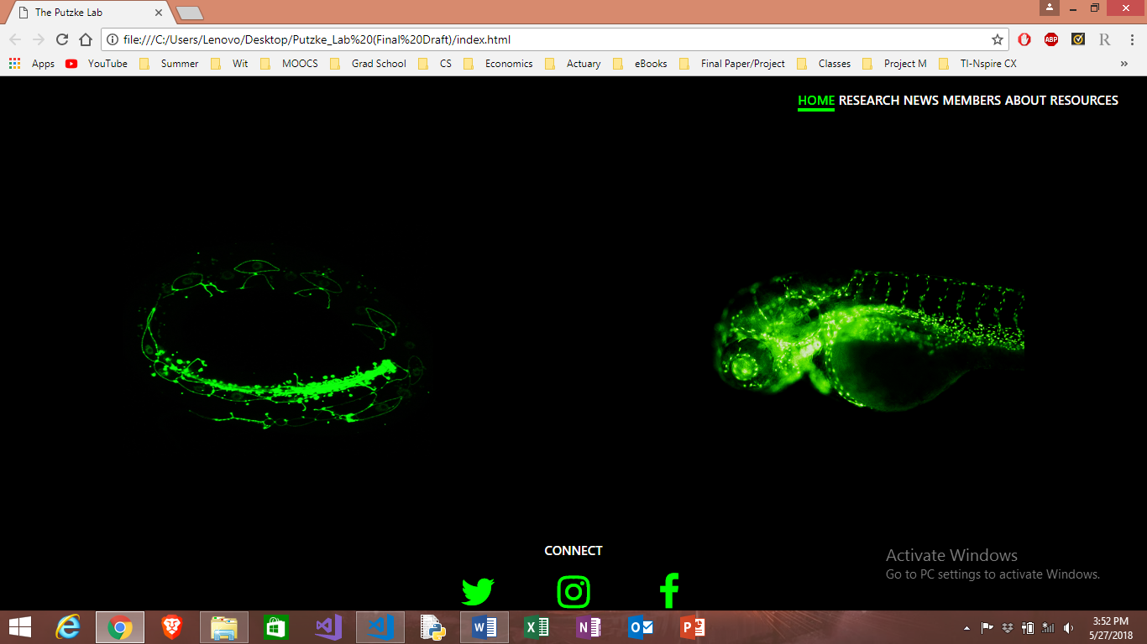

**After**

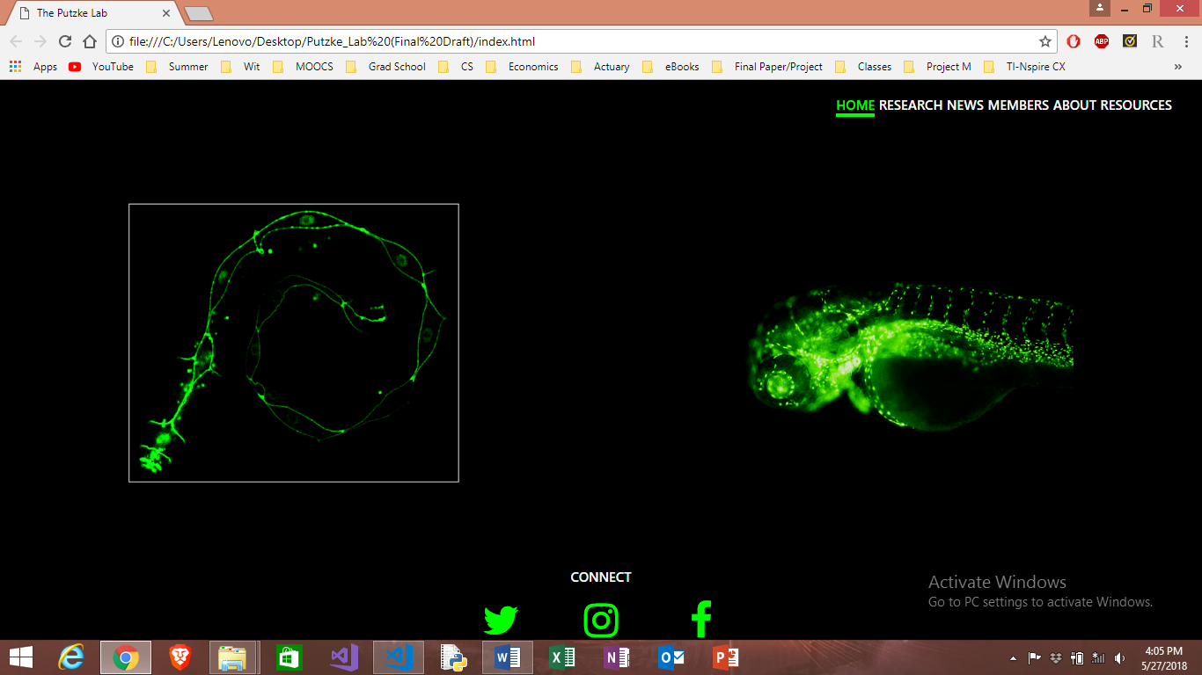

**Research: Swapping Pictures**

* **Open “…/pages/Research_xxx.html” with text editing software**

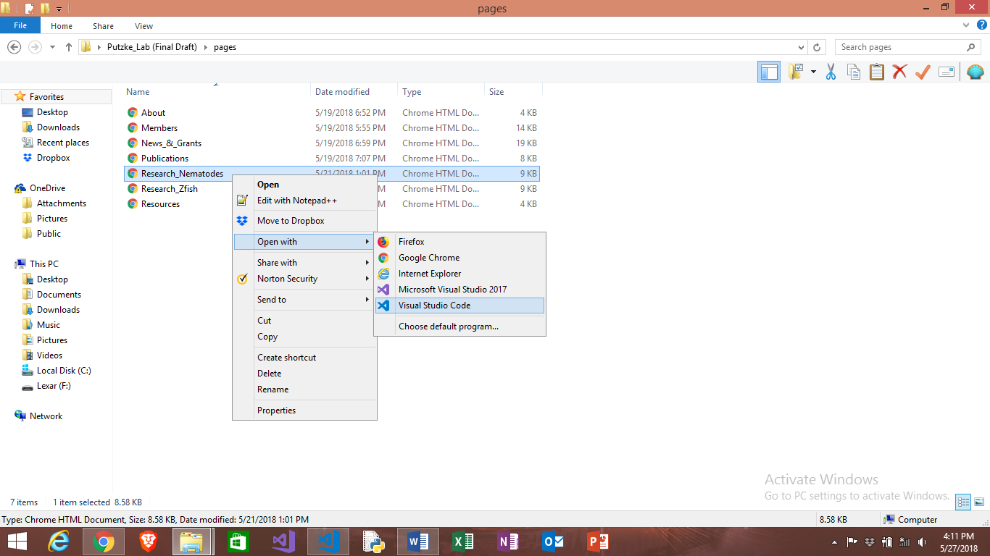

* **Find name of desired image in “…/images/Research”** 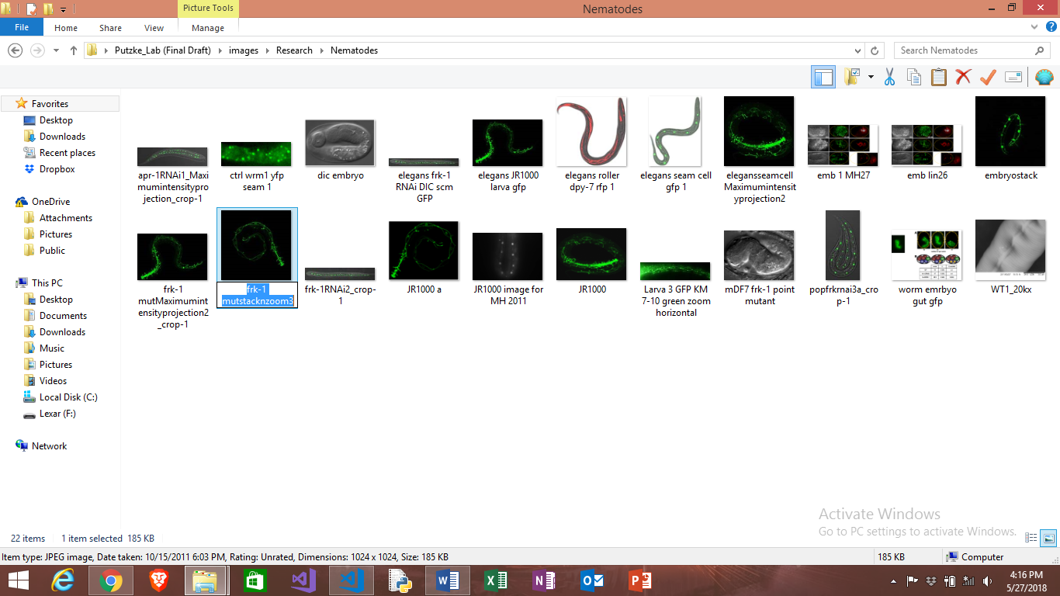
* **Change name of image title to desired picture from folder**

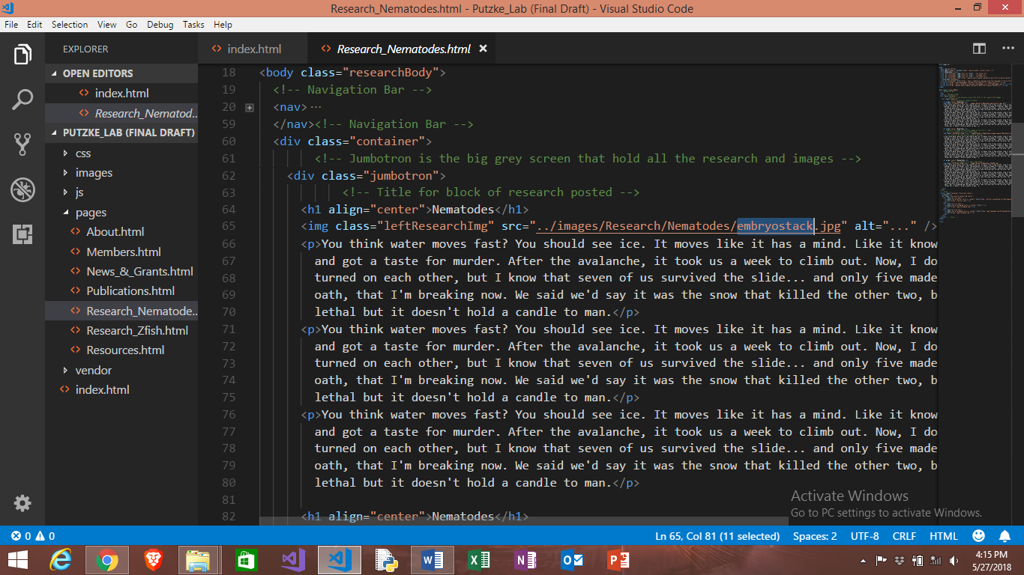

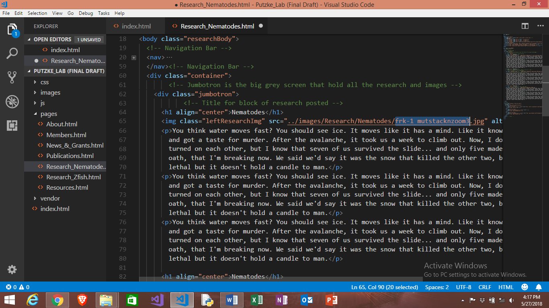

**Before**

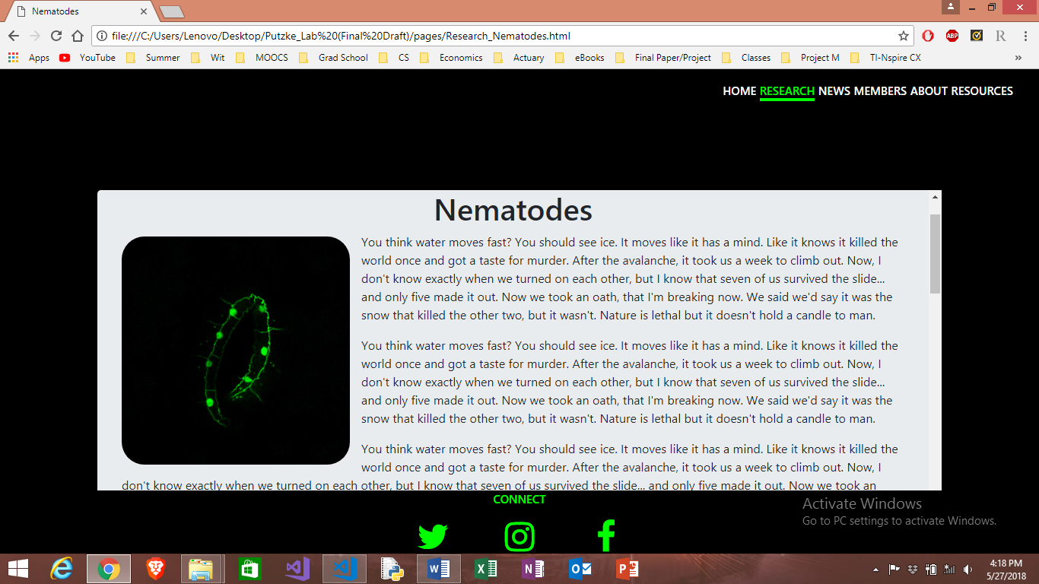

**After**

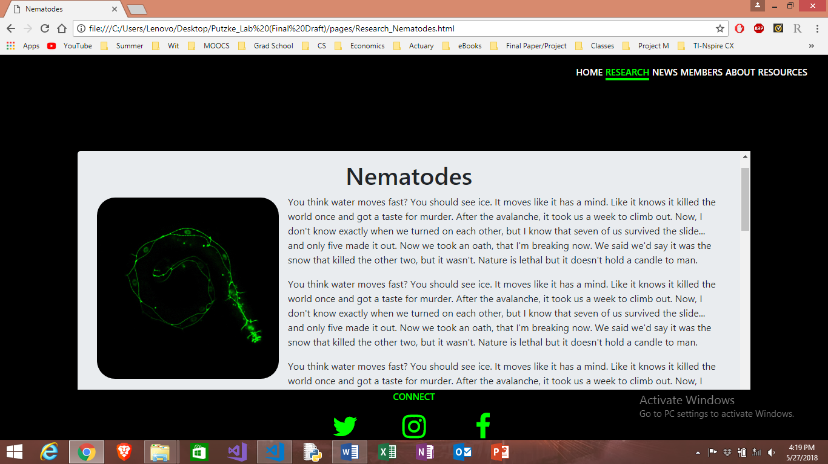

**Research: Editing Text**

* **Find the first “<p>… </p>” section under the desired picture you would like to change (as highlighted below) and edit.**

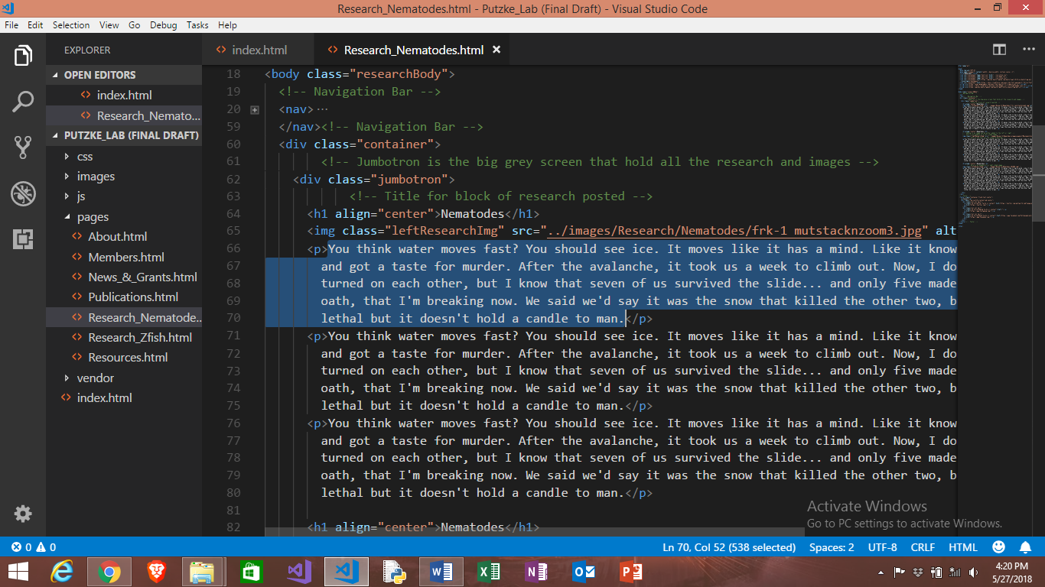

**Research: Adding Picture and Section**

* **Copy and paste the following code to add section:**

**Note: “Nematodes” is where the heading for that image would go**

**(code for image on left)**

<h1 align="center">Nematodes</h1> <!--Title-->

<img class="leftResearchImg" src="../images/Research/Nematodes/frk-1 mutstacknzoom3.jpg" alt="..." />

<p> (text goes here)

</p>

**(code for image on right)**

<h1 align="center">Nematodes</h1> <!--Title-->

<img class="rightResearchImg" src="../images/Research/Nematodes/elegansseamcellMaximumintensityprojection2.jpg" />

<p> (text goes here)

</p>

**(without heading) Exclude line of code labeled “Title” as shown below**

<h1 align="center">Nematodes</h1> <!--Title-->

**Note: To add new paragraph, copy and paste the following code after image code seen above:**

<p>

</p>

**About: Swapping Pictures**

* **Open “…/pages/About.html” with text editing software**

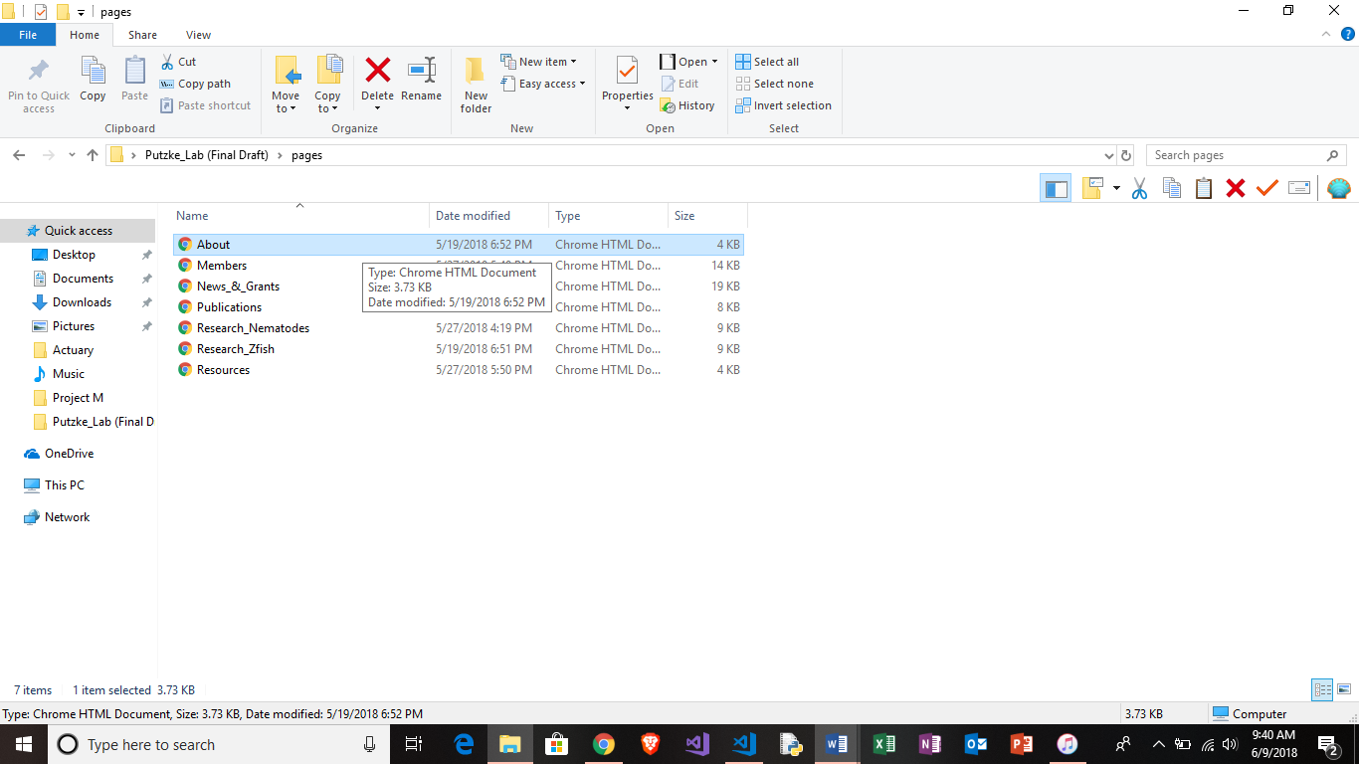

* **Find name of desired image in “…/images/About”**

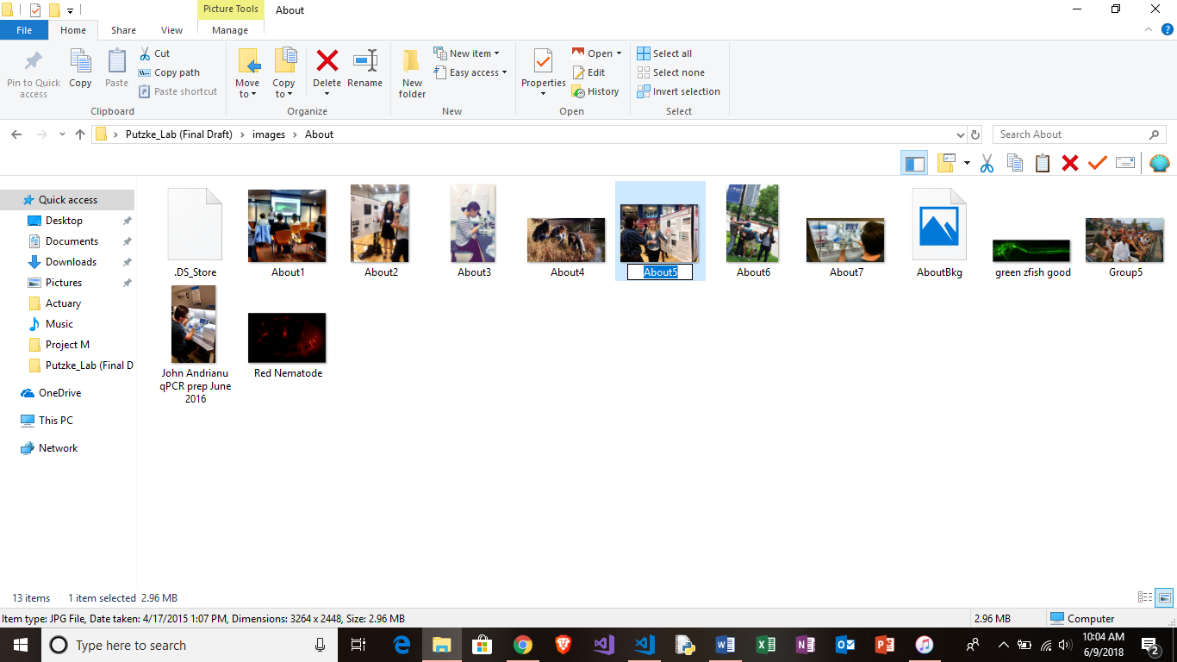

* **Change name of image title to desired picture from folder**

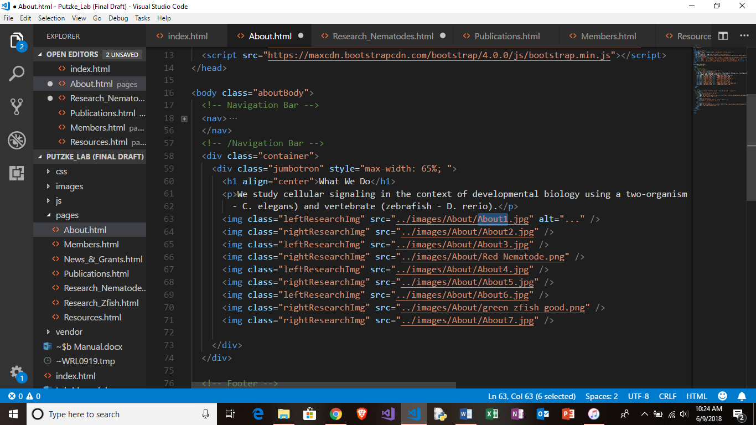

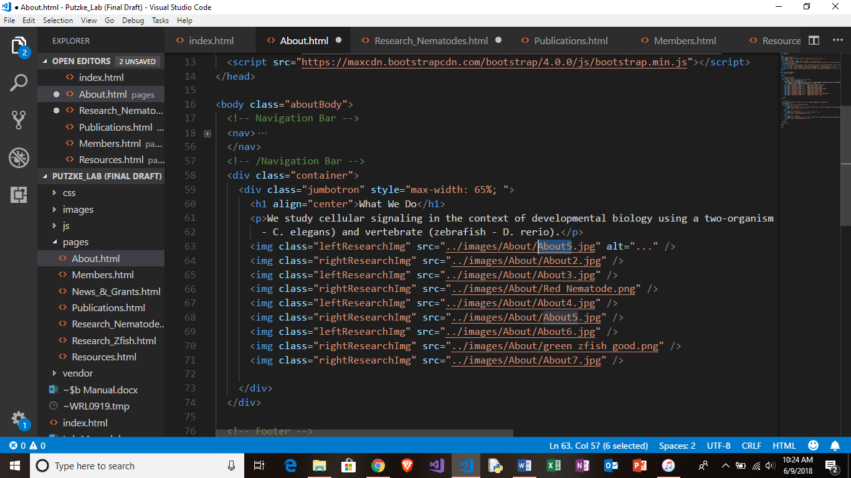

**Before**

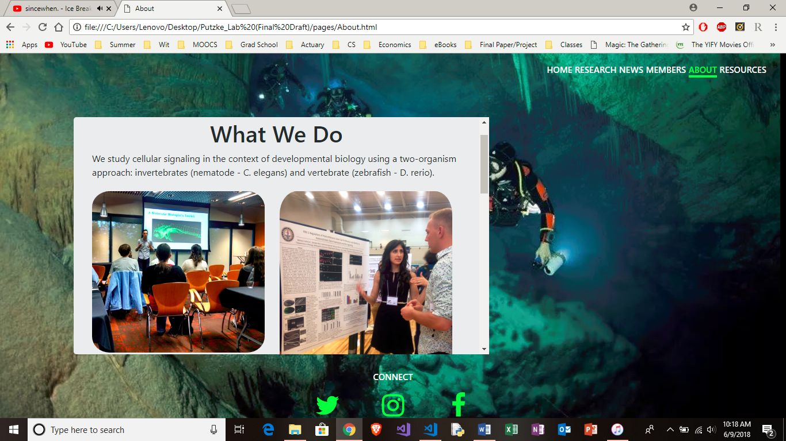

**After**

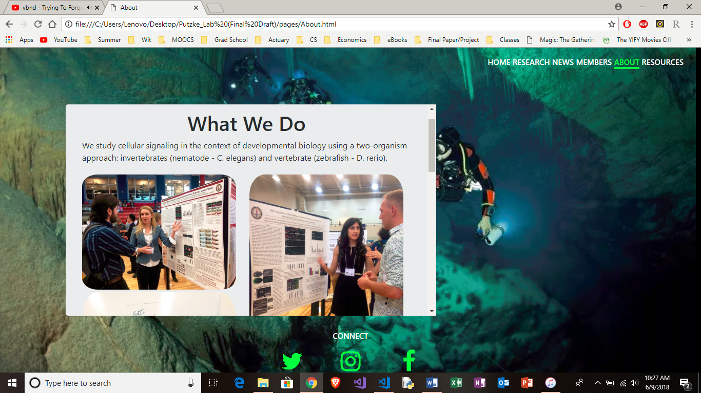

**About: Editing/Adding Text**

* **Find the “<p>… </p>” section under the labeled title line (as highlighted below) and edit description.**

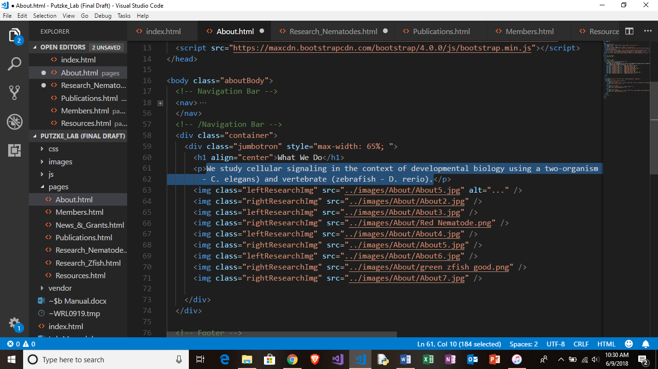

**About: Adding Picture**

* **Copy and paste the following code to add new picture:**

**(code for image on left)**

<img class="leftResearchImg" src="../images/About/About1.jpg" />

**(code for image on right)**

<img class="rightResearchImg" src="../images/About/About7.jpg" />

**Before**

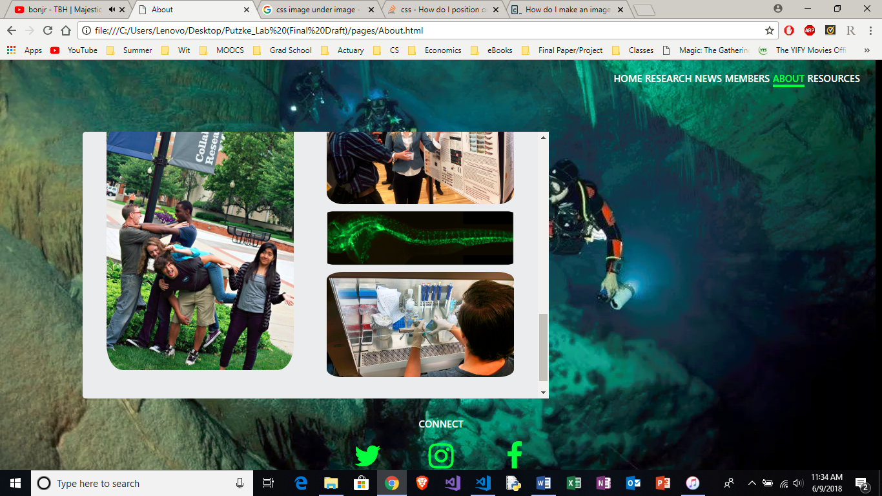

**After**

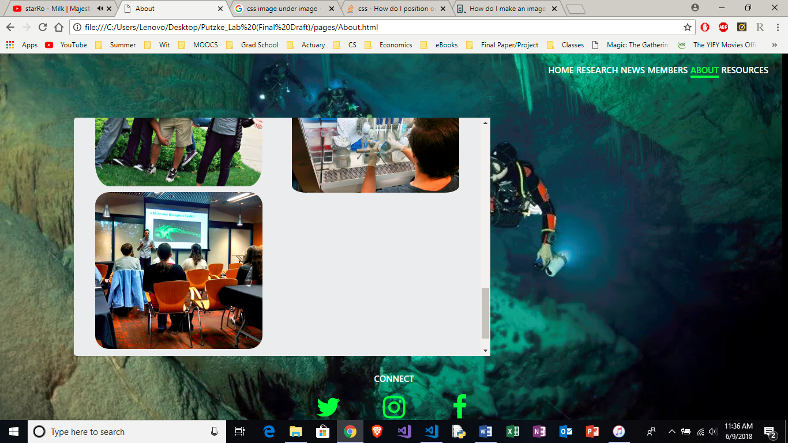

**Resources: Swapping Pictures**

* **Open “…/pages/Resources.html” with text editing software**

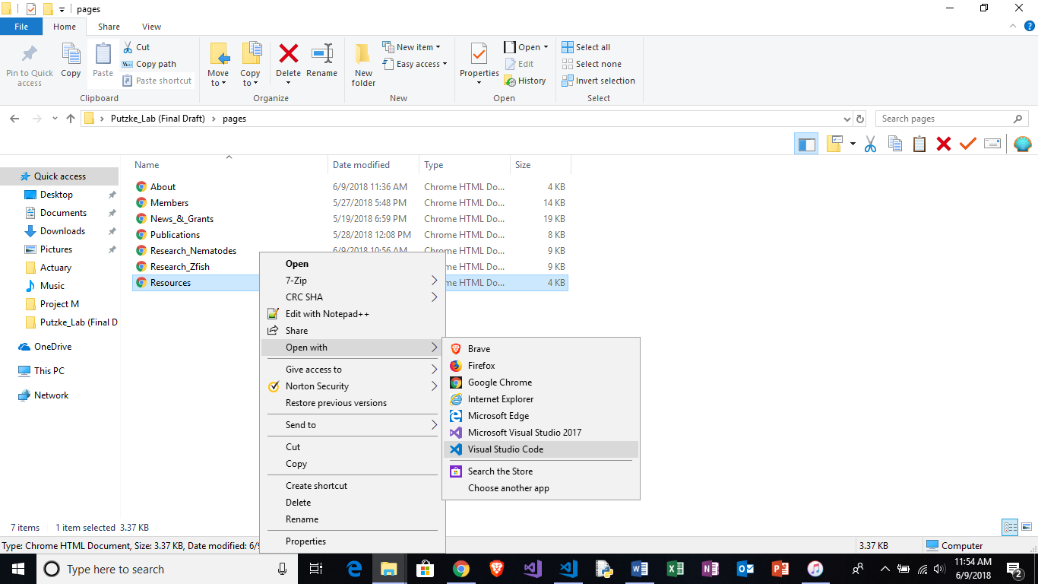

* **Find name of desired image in “…/images/Resources**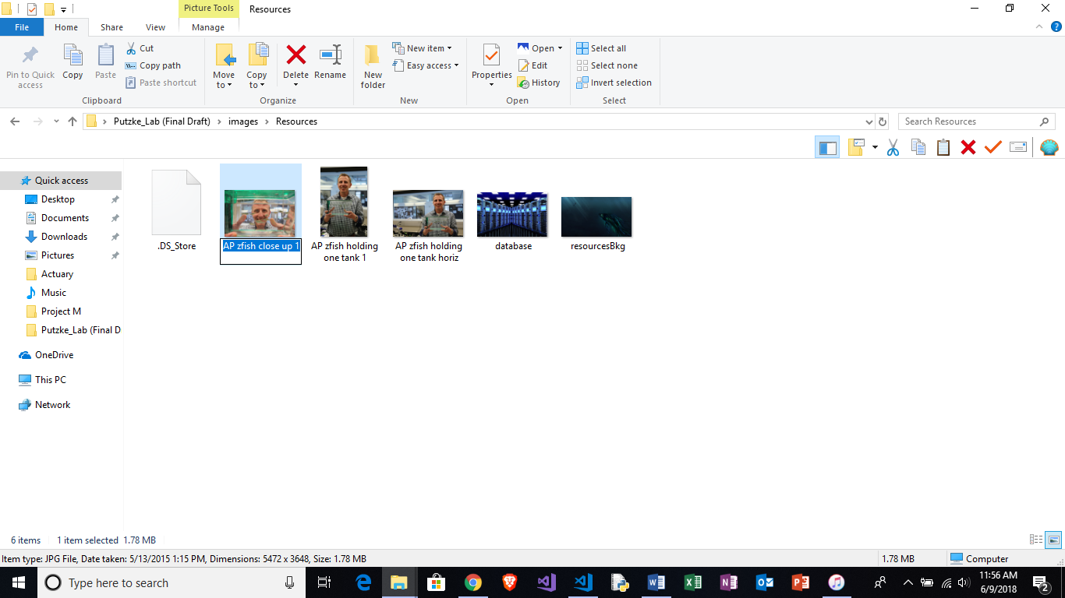
* **Change name of image title to desired picture from folder**

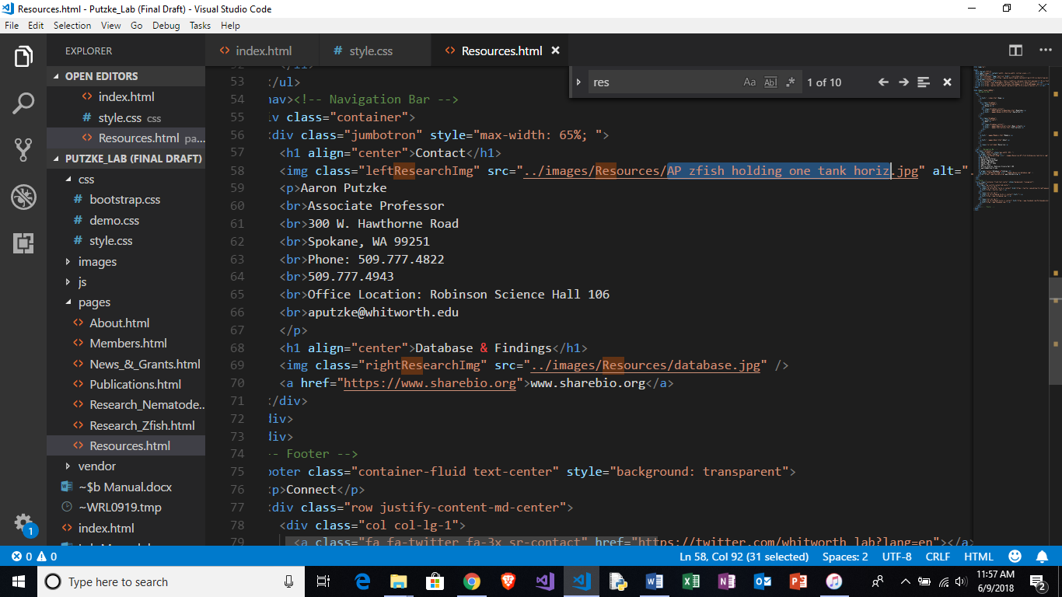

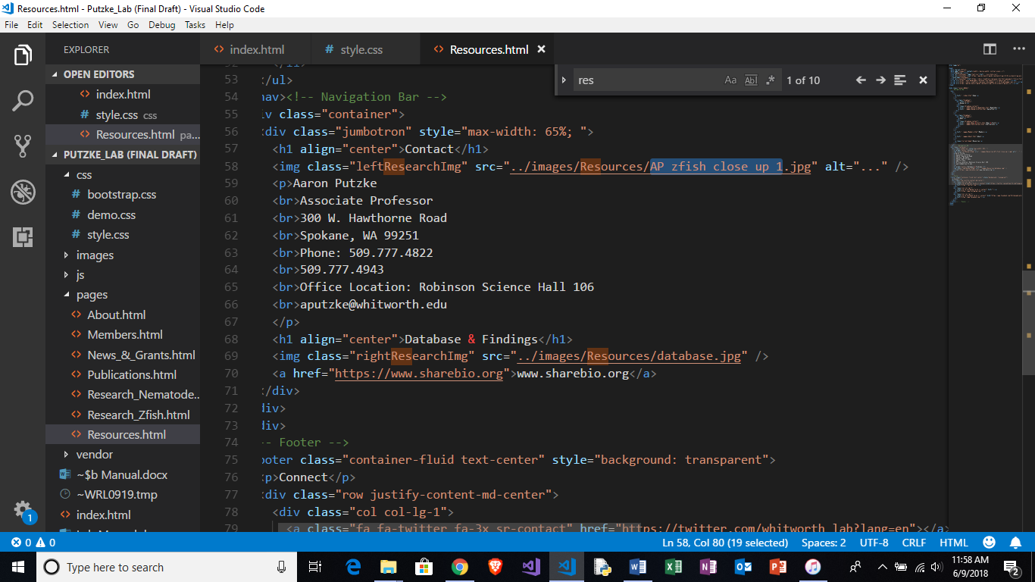

**Before**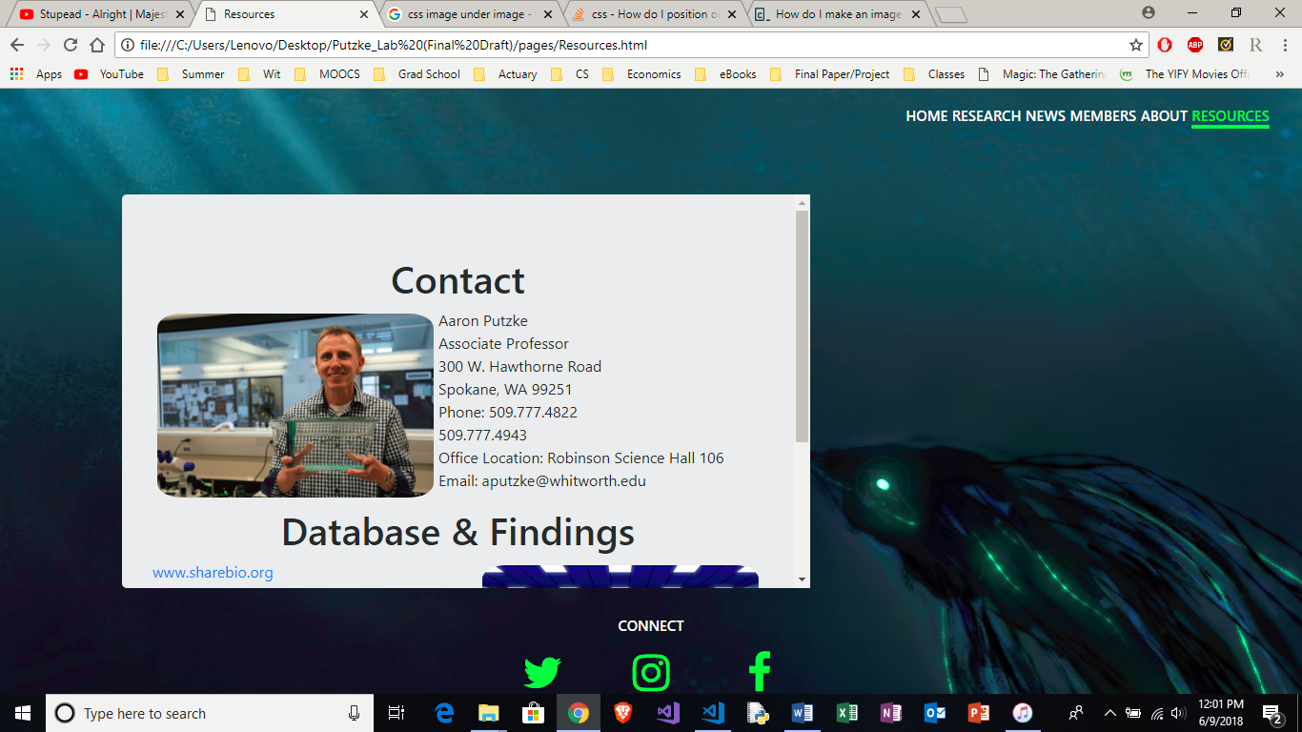

**After**

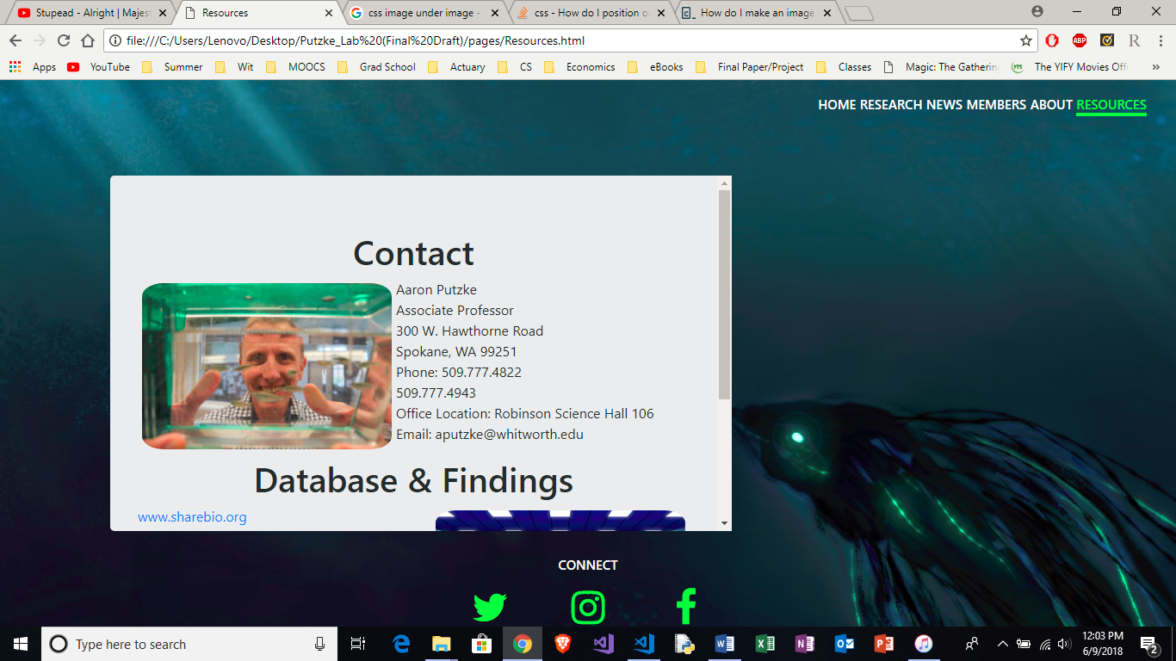

**General News/Grants: Swapping Pictures**

* **Open “…/pages/News_&_Grants.html” with text editing software**

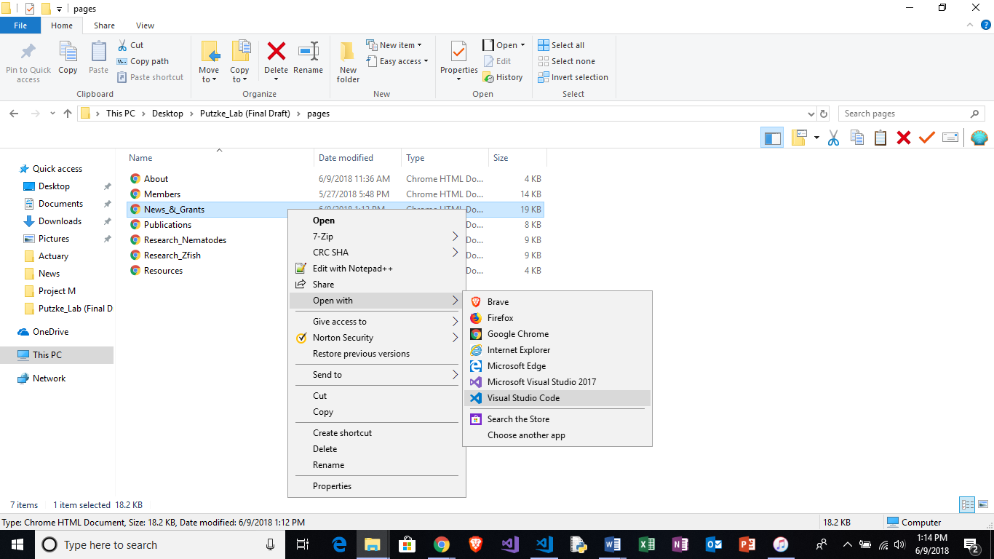

* **Find section you wish to edit**

**Note: Sections are in reverse chronological order**

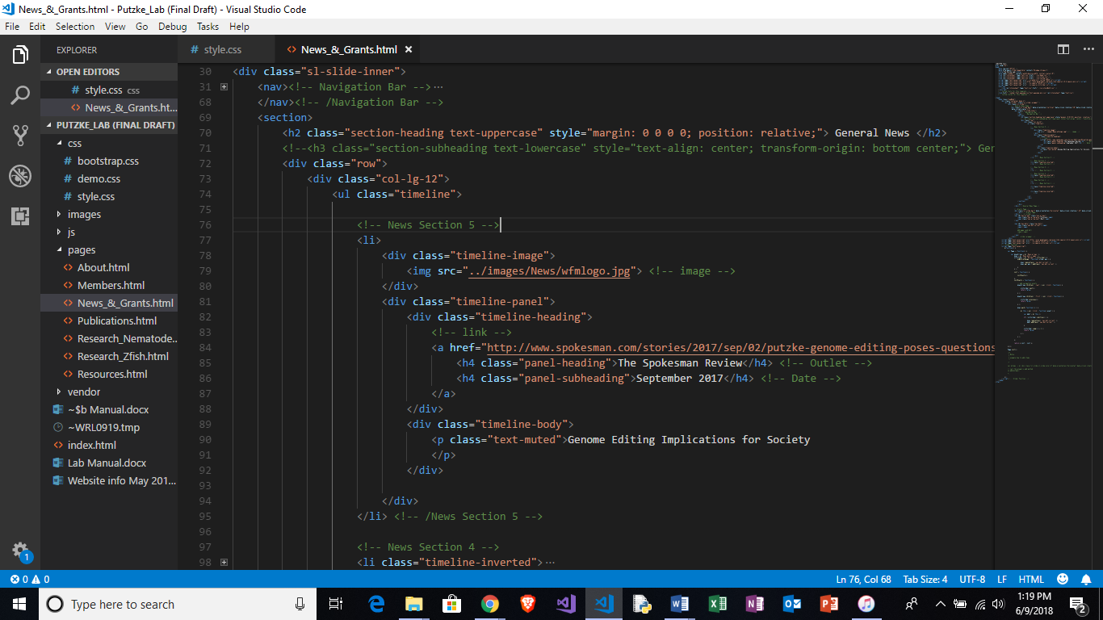

* **Find name of desired image in “…/images/News**

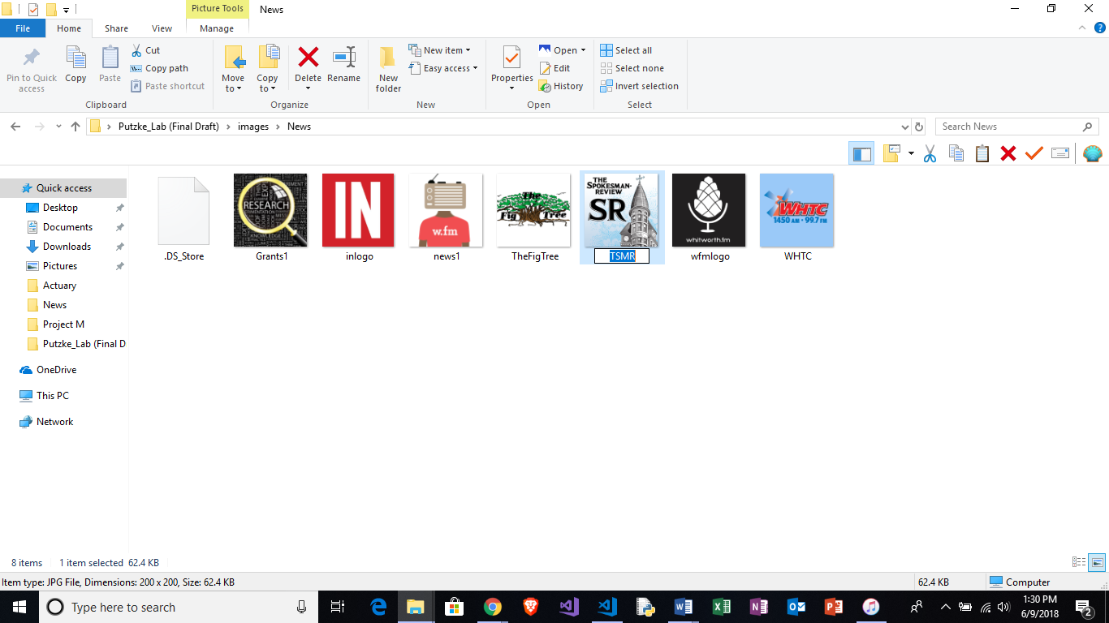

* **Change name of image title to desired picture from folder**

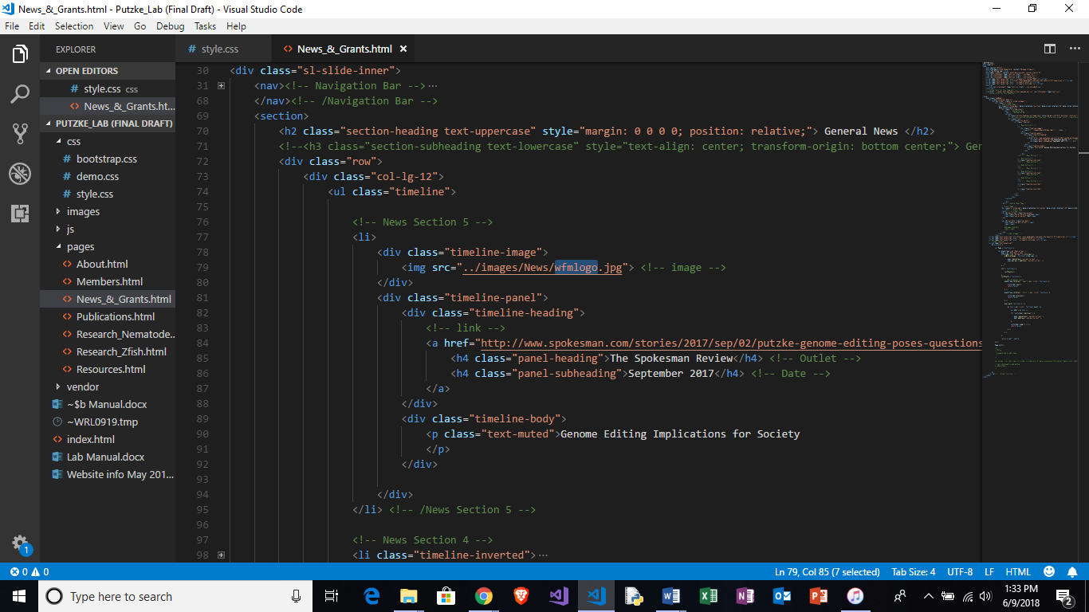

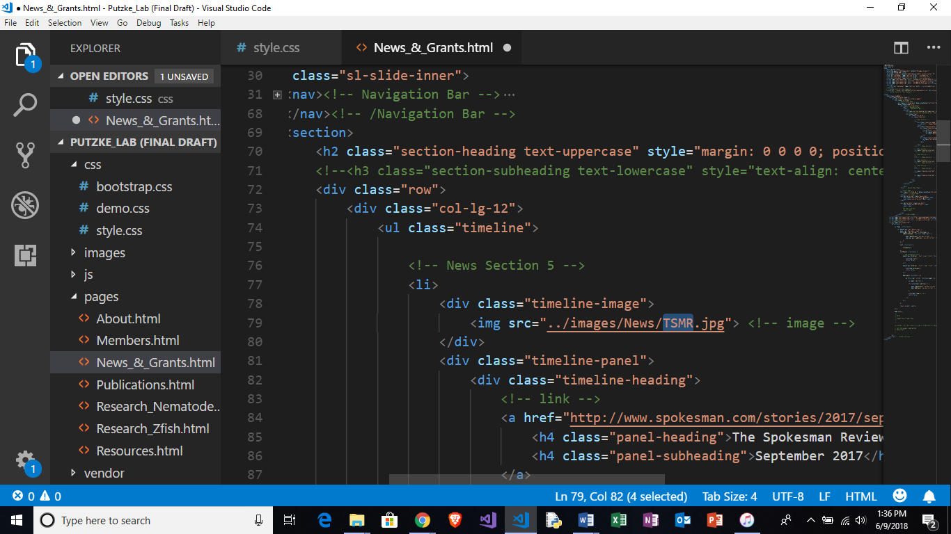

**Before**



**After**



**General News/Grants: Editing Text**

* **Find section you wish to edit**

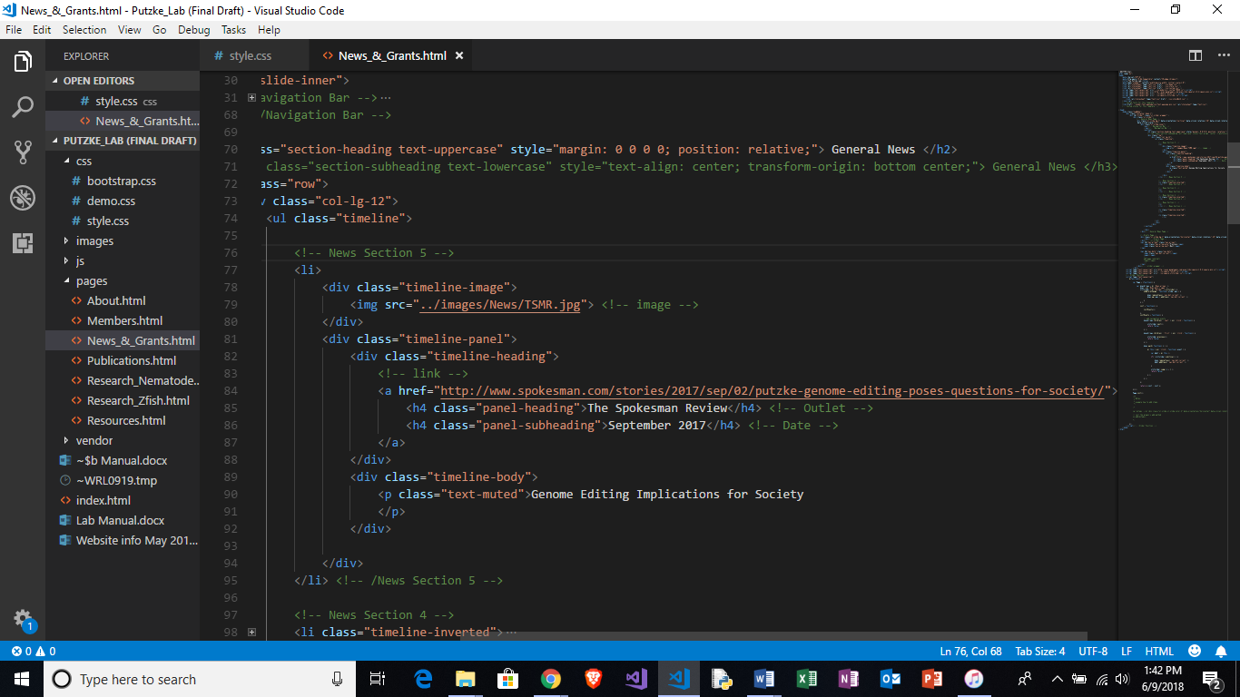

* **To edit/add a link, find line titled “link” and paste desired link within link section as highlighted below**

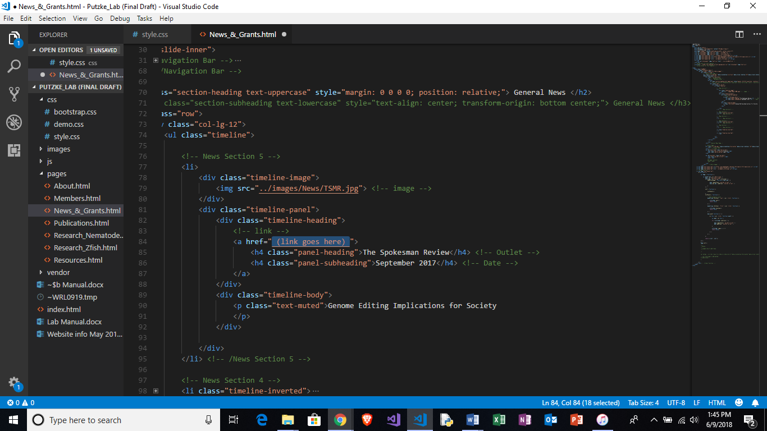

**Note: link must be within quotation marks**

* **To edit/add the outlet name, find line titled “Outlet” and paste desired name within section highlighted below**

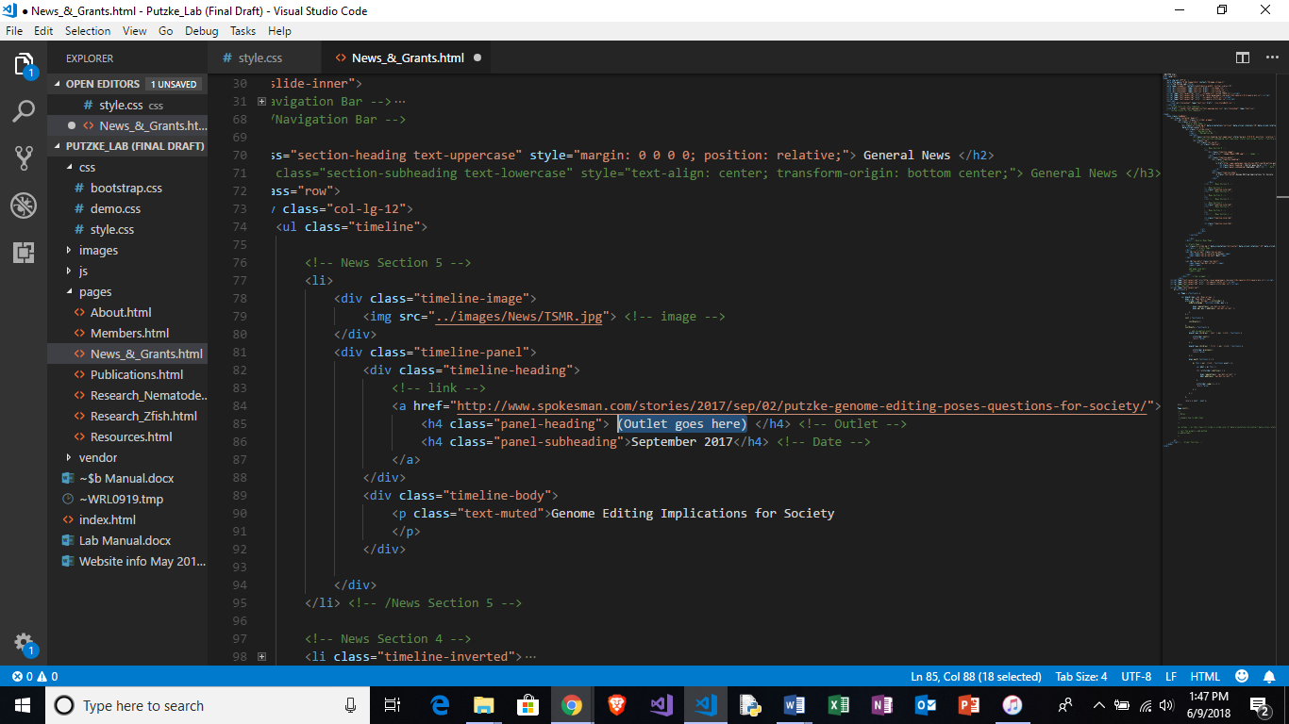

* **To edit/add the date name, find line titled “Date” and paste desired date within section highlighted below**

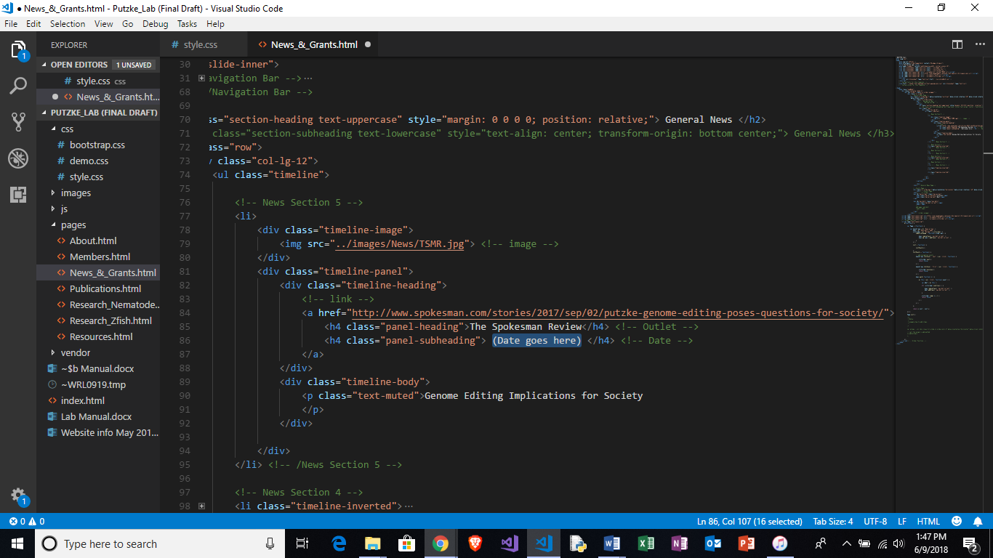

**General News/Grants: Add section**

* **Scroll to the first labeled section**



* **Copy section from line title “<!—News Section # -->” to line titled**

**“<! --/News Section # -->”**

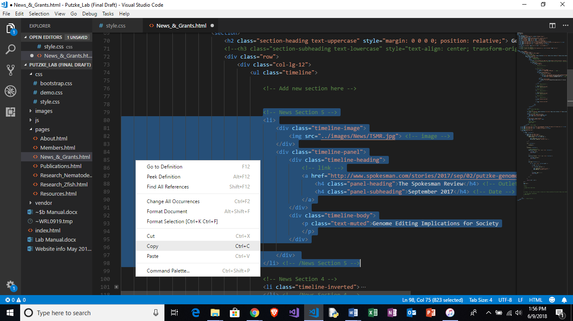

* **Paste copied section under line titled “Add new section here”**

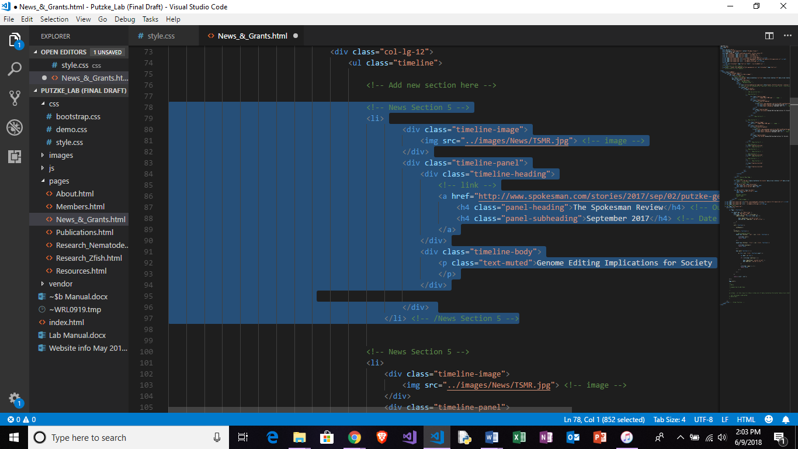

* **Be sure to update the new section with correct number above and below code**
* **If the previous top-most section began as shown below:**

<!-- News Section # -->

<li>

**replace corresponding code in the new copied section with the following code:**

<!-- News Section #+1 -->

<li class="timeline-inverted">

* **If the previous top-most section began as shown below:**

<!-- News Section # -->

<li class="timeline-inverted">

**replace corresponding code in the new copied section with the following code:**

<!-- News Section #+1 -->

<li>

**Below is an example of a newly added and fully updated section**

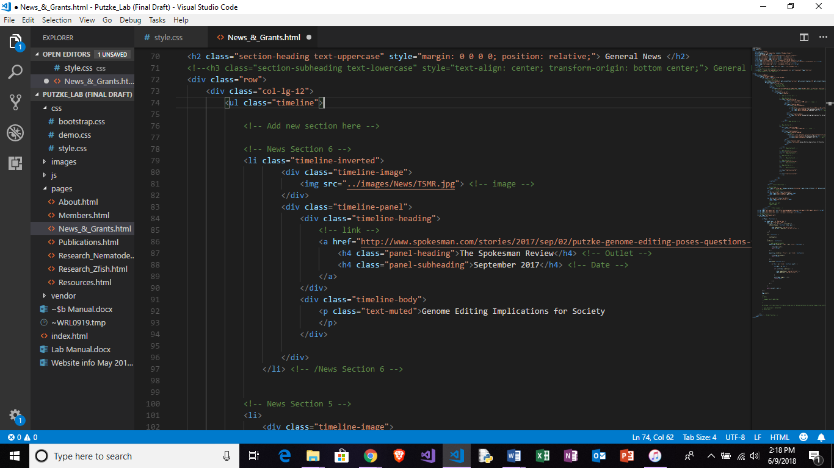

**Note: templates for both the standard and inverted timeline sections can be found below the line titled “Templates”**

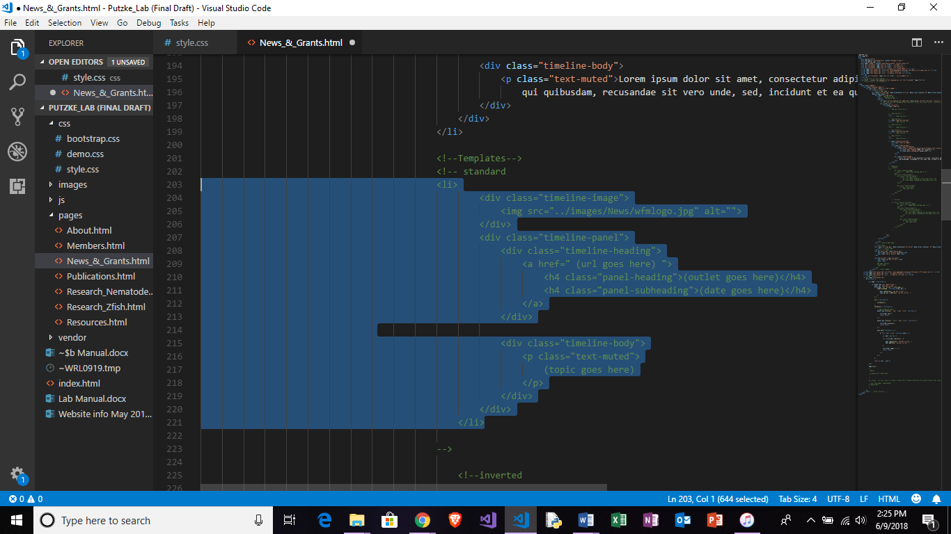

* **The “Grants” section is found after the line titled “Grants Page” after the General News section concludes**
* **The “Grants” section is formatted identically to the news section with additional section for funding amounts**
* **Adding/editing images, text, and sections follow the same steps as the “General News” section**
* **Templates for both the standard and inverted timeline sections (grants) can be found below the line titled “Templates”**

**Publications**

* **The “Publications” page is formatted identically to the news section**
* **Adding/editing images, text, links, and sections follow the same steps as the “General News” section**
* **Templates for both the standard and inverted timeline sections (publications) can be found below the line titled “Templates”**

**Lab Members: Swapping Member Pictures**

* **Open “…/css/style.html” with text editing software**

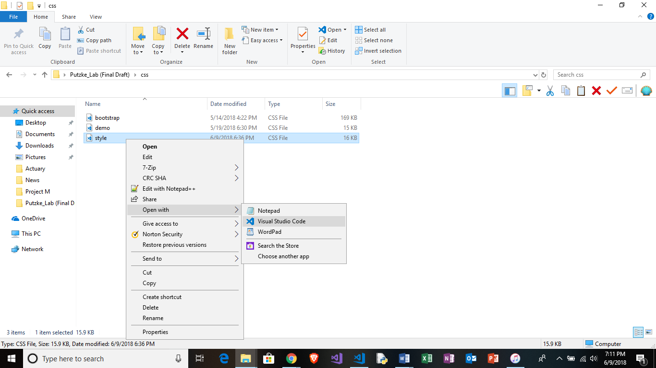

* **Find name of desired image in “…/images/Lab_Members**

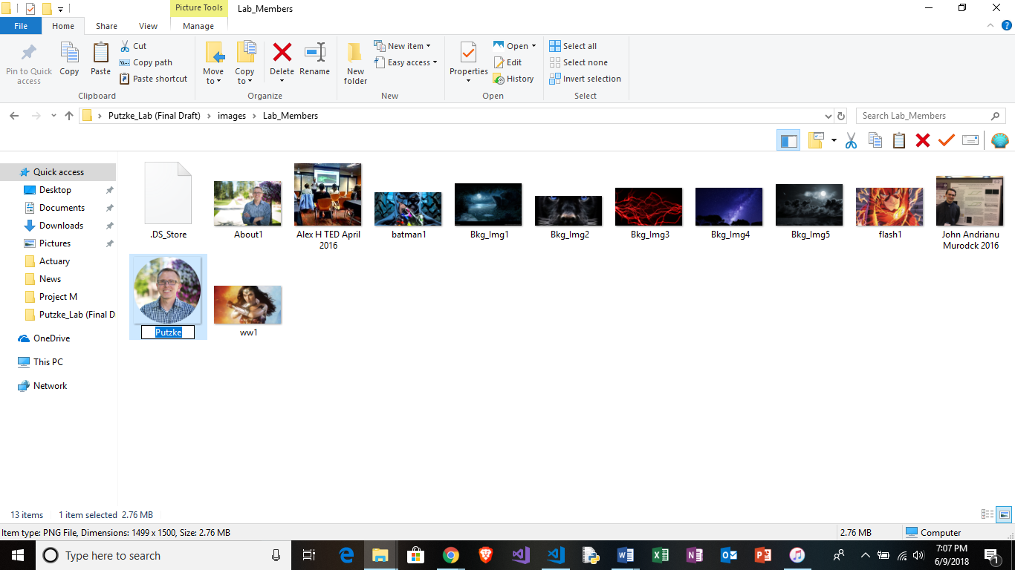

* **Find section Titled “Lab Members”**

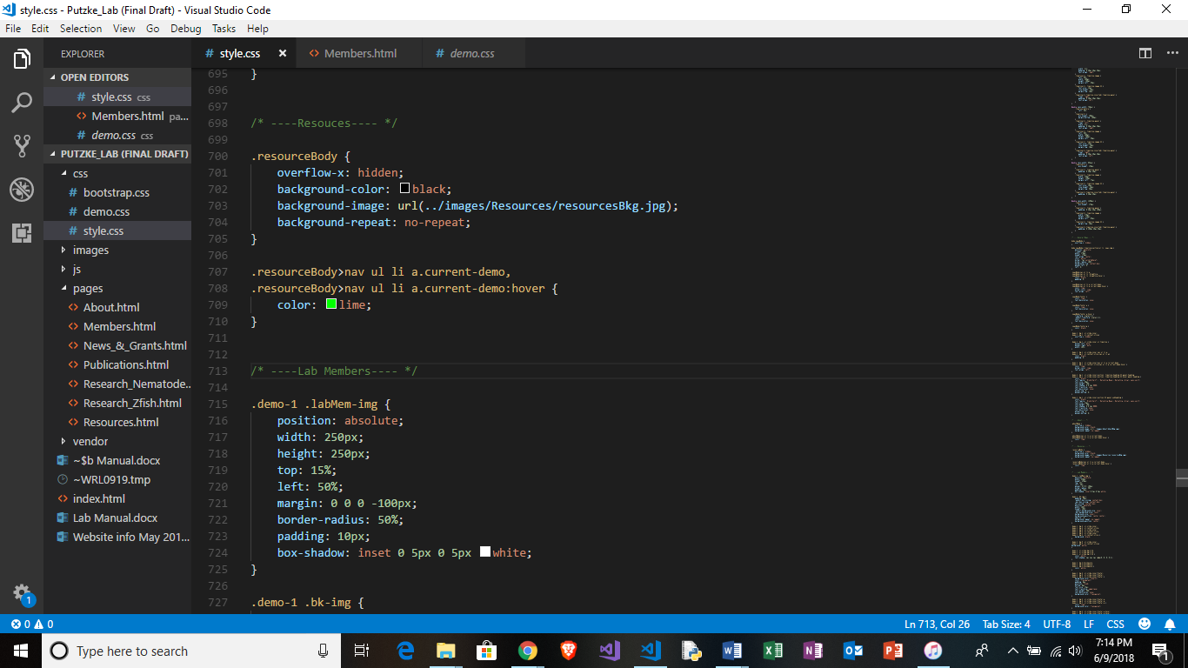

* **Continue scrolling until desired lab member name is found**

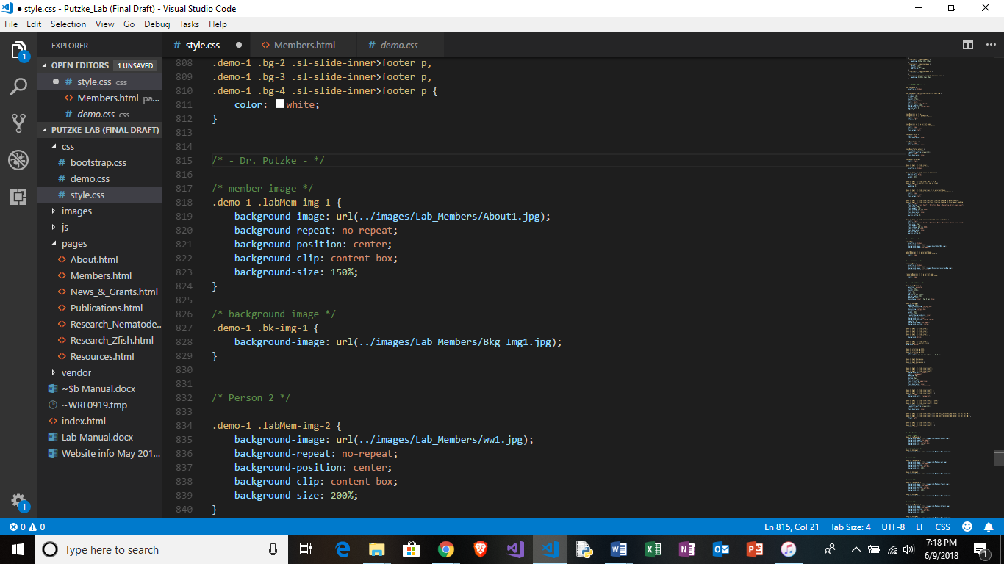

* **Change name of image title to desired picture from folder**

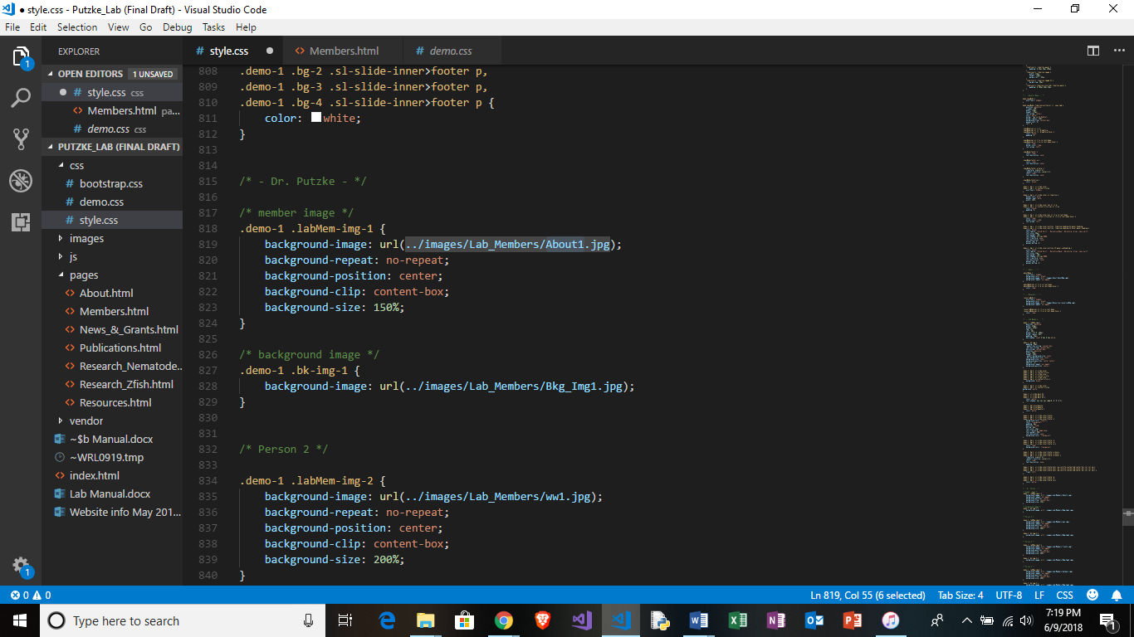

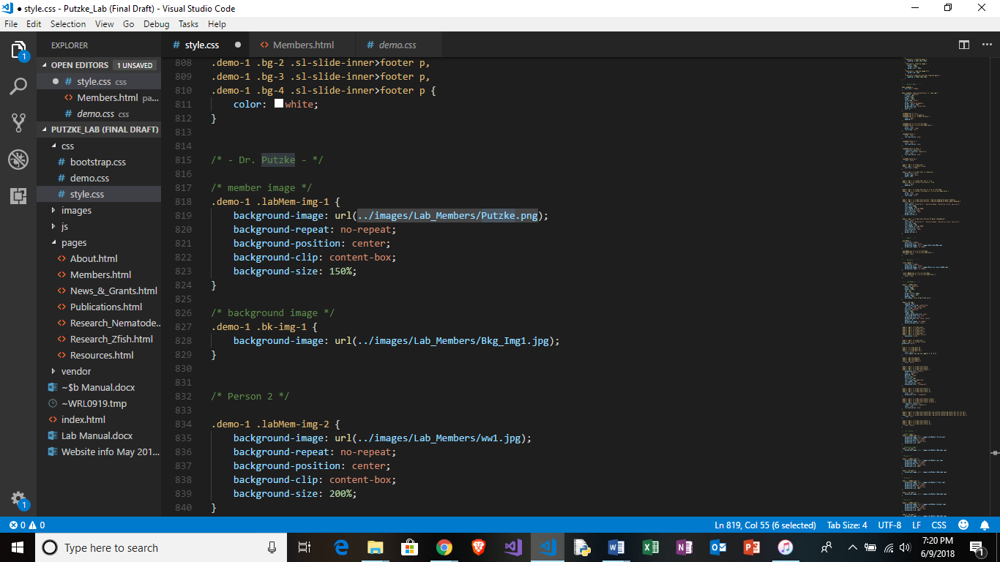

**Before**

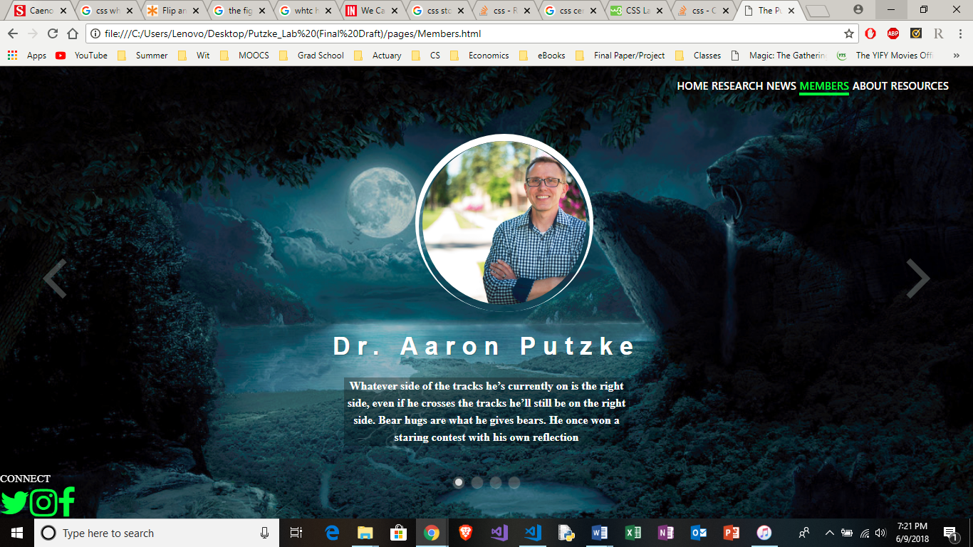

**After**



**Lab Members: Swapping Background Pictures**

* **Open “…/css/style.html” with text editing software**



* **Find name of desired image in “…/images/Lab_Members**

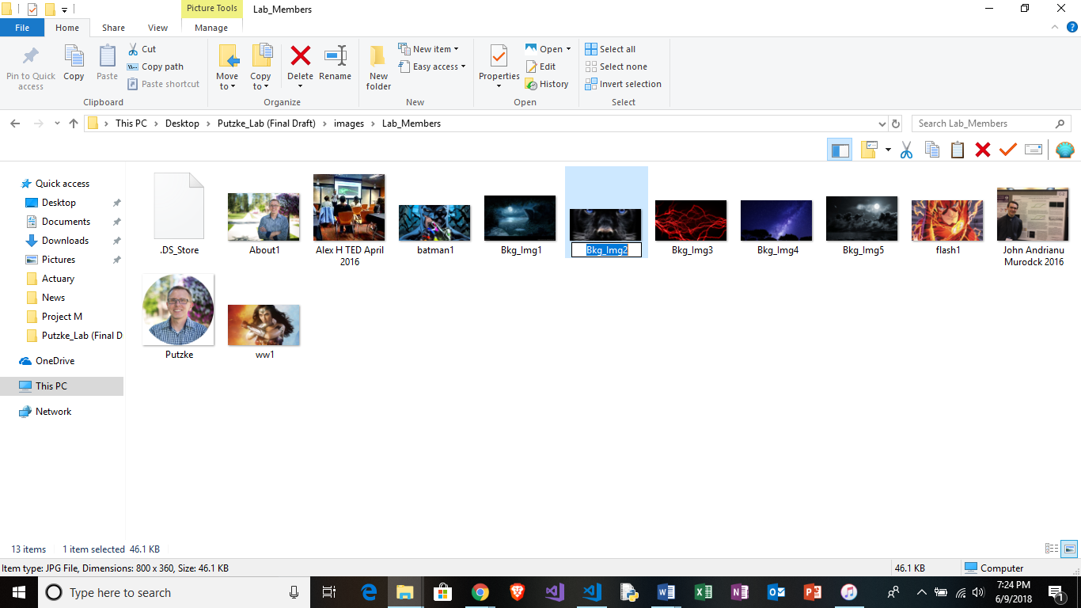

* **Change name of image title to desired picture from folder**

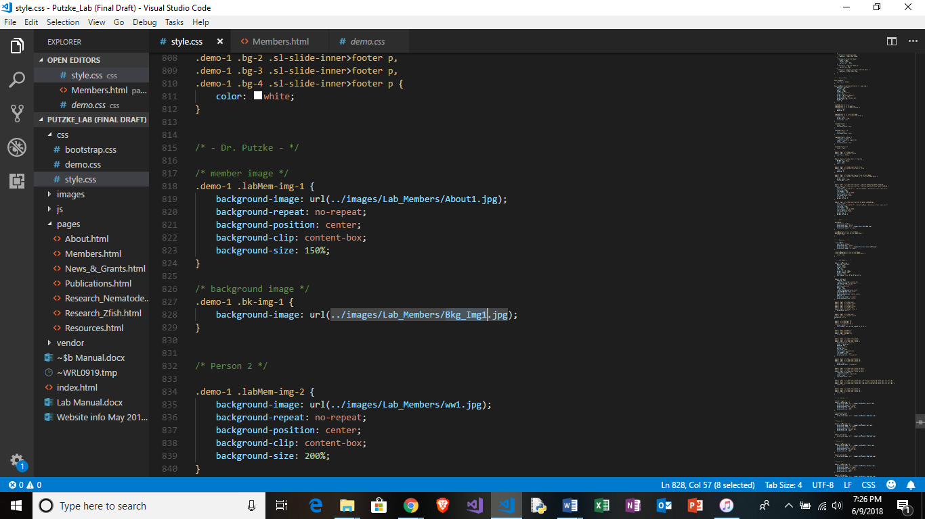

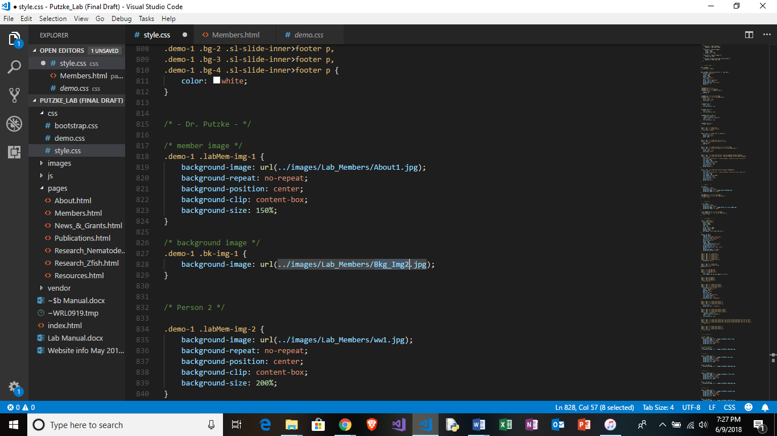

**Before**



**After**

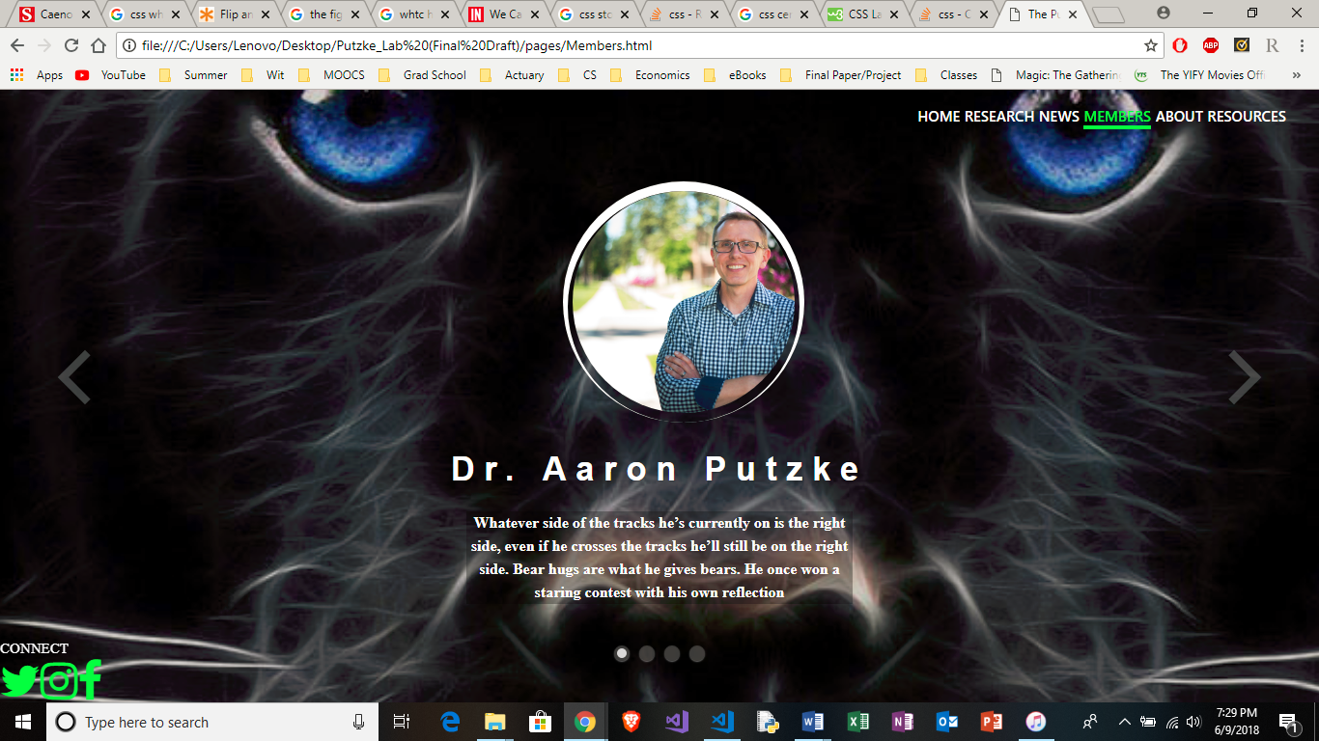

**Lab Members: Editing Text**

* **“…/pages/Members.html” with text editing software**

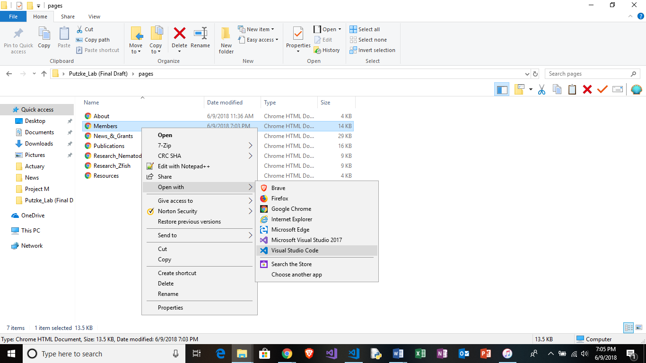

* **Find section of desired lab member**
* **Find line labeled “member description”**
* **Paste desired text into section (section shown highlighted below)**

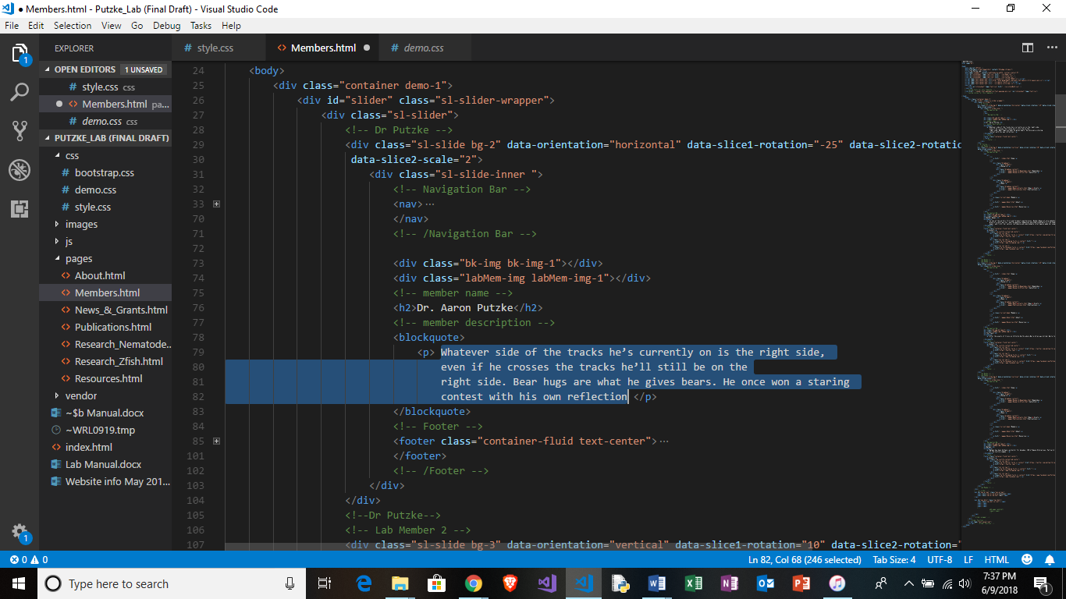

* **To change the lab member name, follow similar steps but text ender line titled “member name” (highlighted below)**

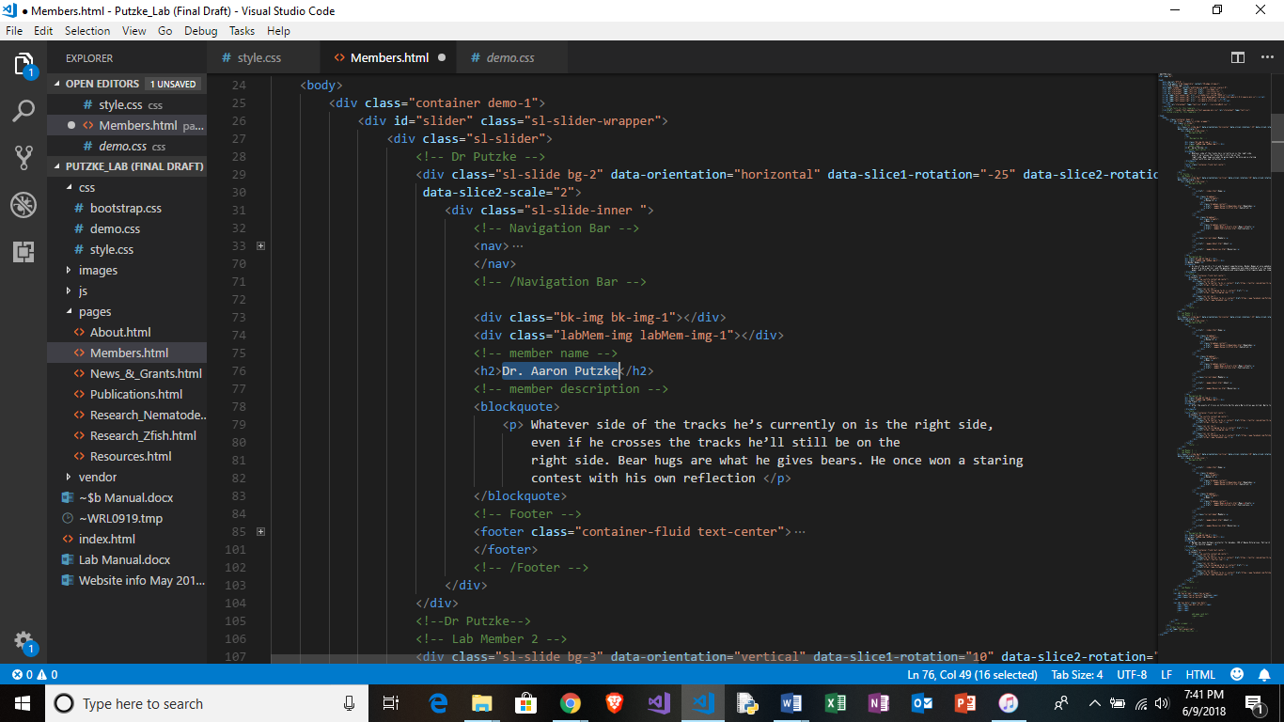

**Lab Members: Adding New Member**

* **Open “…/pages/Members.html” with text editing software**



* **Find line titled “Add new member here”**

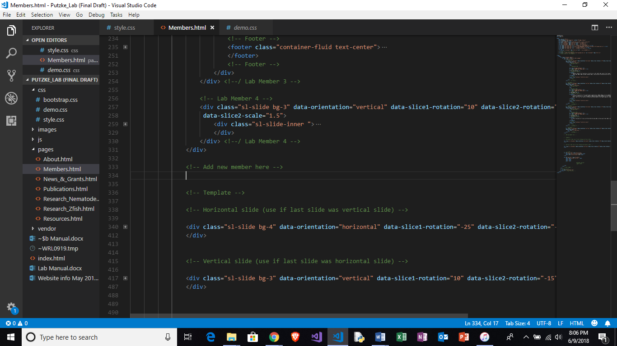

* **Copy and paste desired slide type (vertical or horizontal) under line titled “Add new member here”**

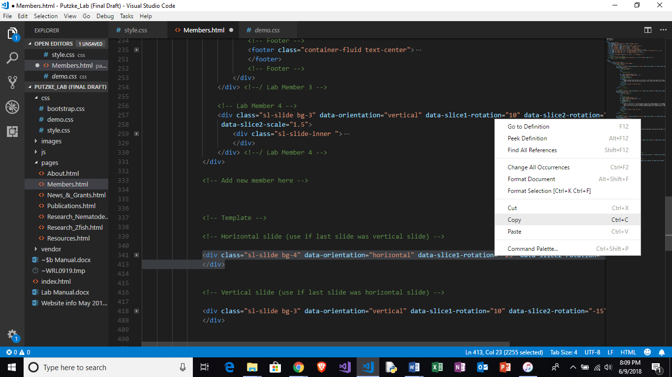

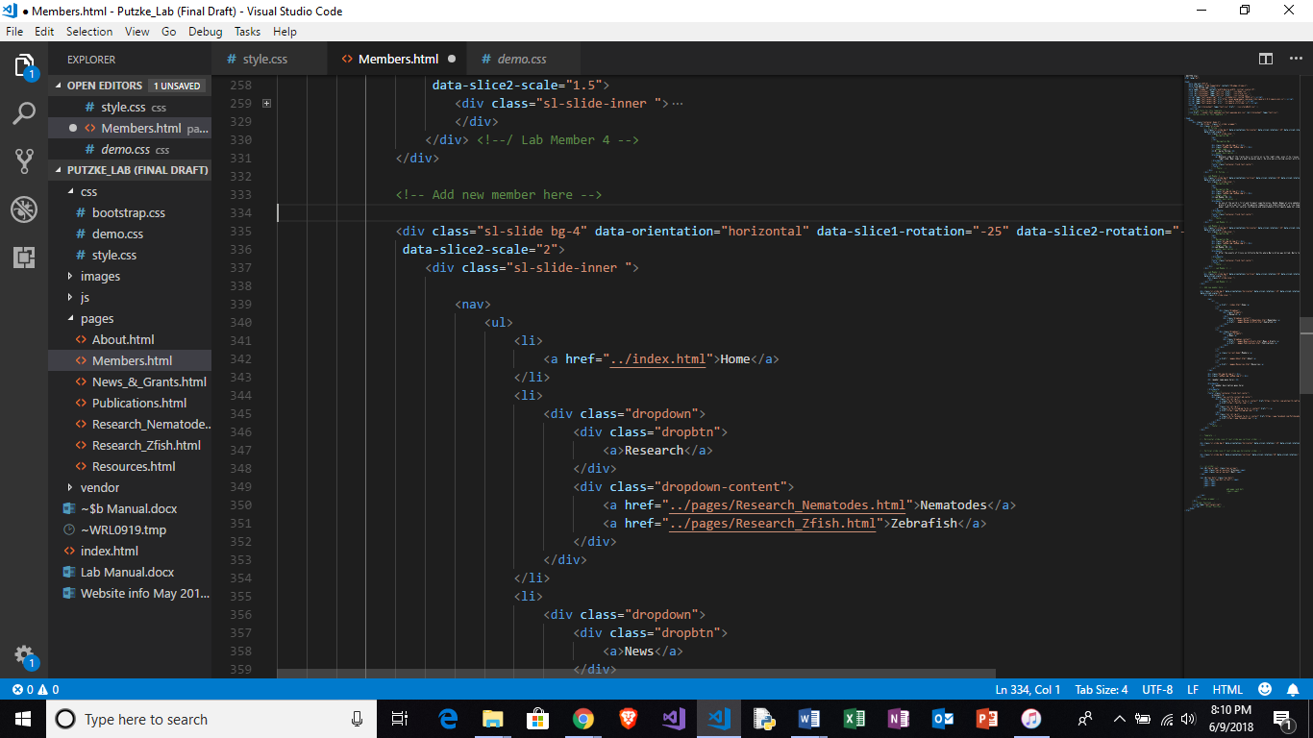

* **Find line labeled “(Footer goes here)” in newly pasted section**

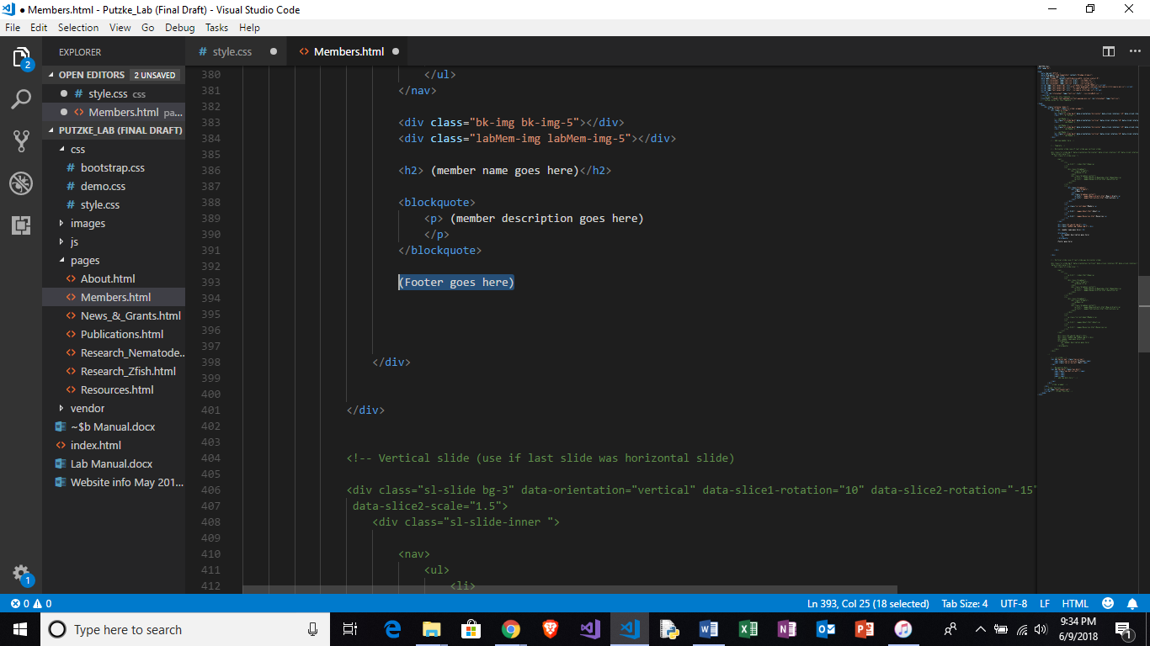

* **Copy & paste the following code over that label**

<!-- Footer -->

<footer class="container-fluid text-center">

<p>Connect</p>

<div class="row justify-content-md-center">

<div class="col col-lg-1">

<a class="fa fa-twitter fa-3x sr-contact" href="https://twitter.com/whitworth_lab?lang=en"></a>

<a href="https://twitter.com/"></a>

</div>

<div class="col col-lg-1">

<a class="fa fa-instagram fa-3x sr-contact" href=""></a>

<a href="https://www.instagram.com/"></a>

</div>

<div class="col col-lg-1">

<a class="fa fa-facebook fa-3x sr-contact" href="https://www.facebook.com/PutzkeLaboratory"></a>

<a href="https://www.facebook.com/"></a>

</div>

</div>

</footer>

<!-- Footer -->

* **Find line labeled “Navigation Dots”**
* **Copy and paste following code above line labeled “add new dots here”**

<span></span>

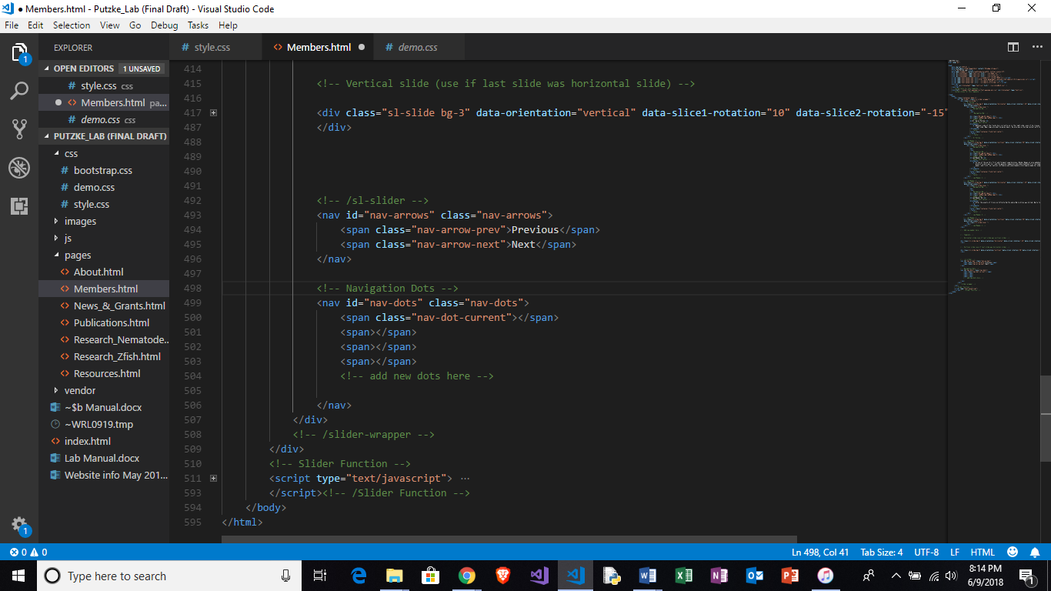

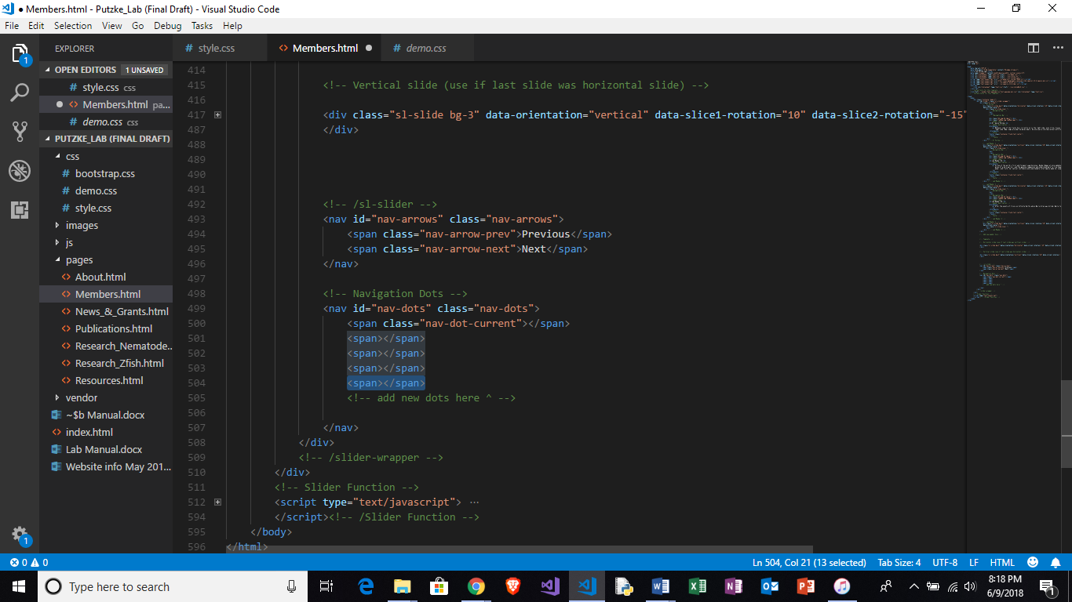

* **Remember to add following line before the newly created section to keep track of which lab member’s section was added**

<!-- Lab Member # -->

* **Remember to add following line before the newly created section to keep track of which lab member’s section was added**

<!--/ Lab Member # -->

* **Open “…/css/style.html” with text editing software**



* **Find section Titled “Lab Members”**



* **Continue scrolling until you reach line labeled “Template”**

**Copy and paste template section (as shown below) under line labeled “Add new lab member here”**

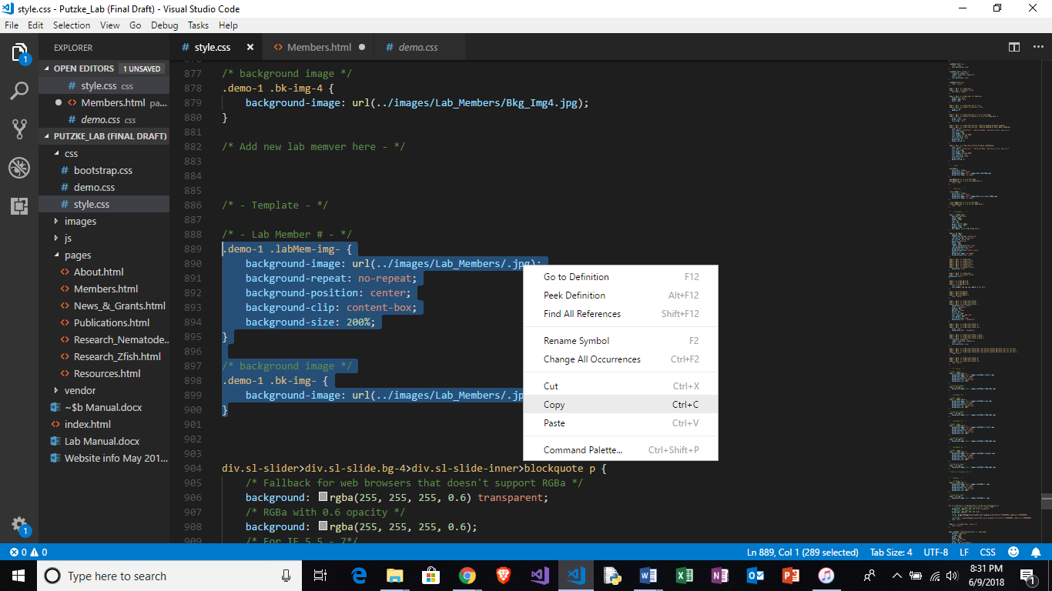

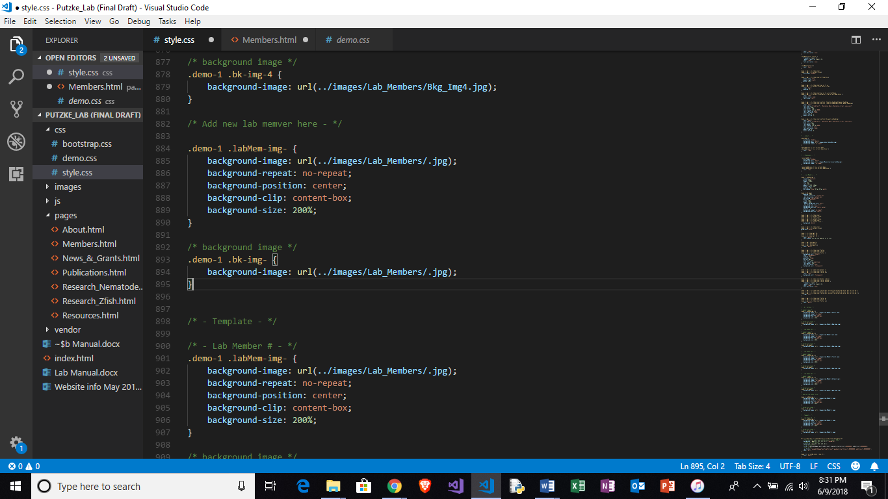

* **The text highlighted below is the name of the new member image for your new member sides**

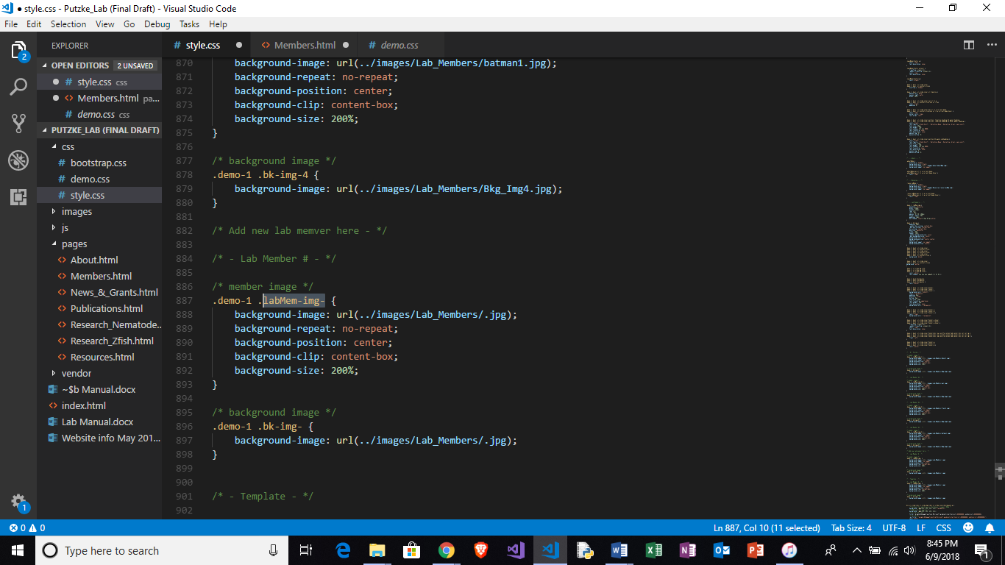

* **You may change the name to something memerable or stay true to the formating in place and lable the image after the coresponding member number like so (highlighted in red):**

/* - Lab Member #5 - */

/* member image */

.demo-1 .labMem-img-5 {

    background-image: url(../images/Lab_Members/.jpg);

    background-repeat: no-repeat;

    background-position: center;

    background-clip: content-box;

    background-size: 200%;

}

* **You must now choose a member image for the new section by selecting a desired image name from “…/images/Lab_Members” and pasted the desired image name into the url path, as shown below:**

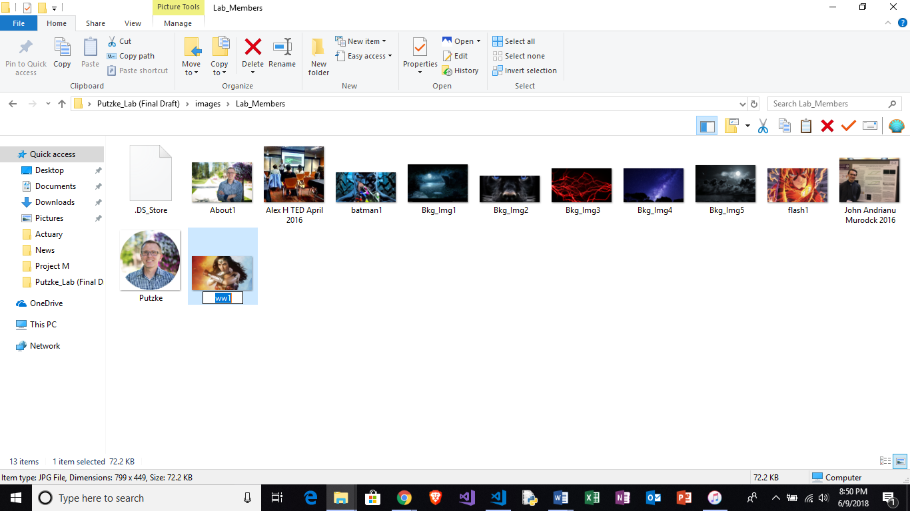

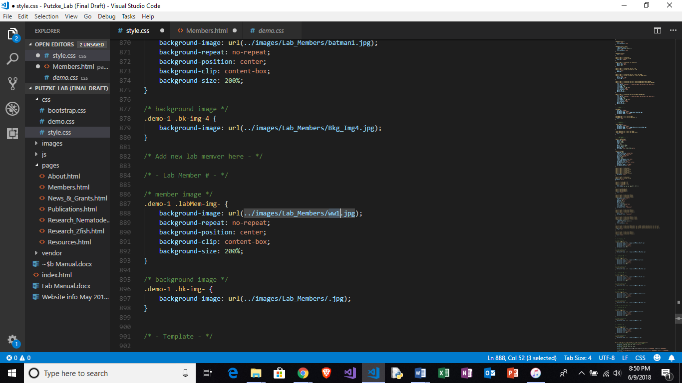

* **Open “…/pages/Members.html” with text editing software**
* **Find corresponding image title in new section and paste new image name**

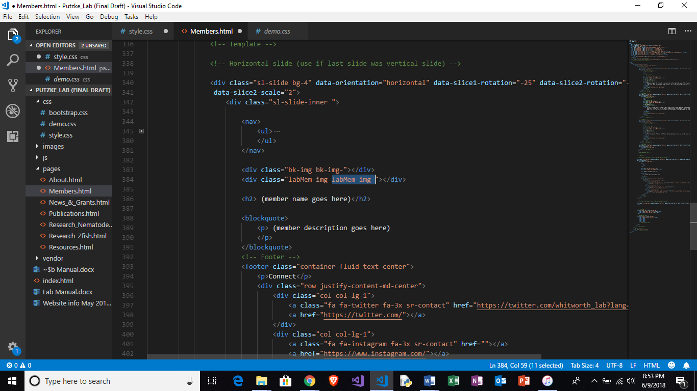

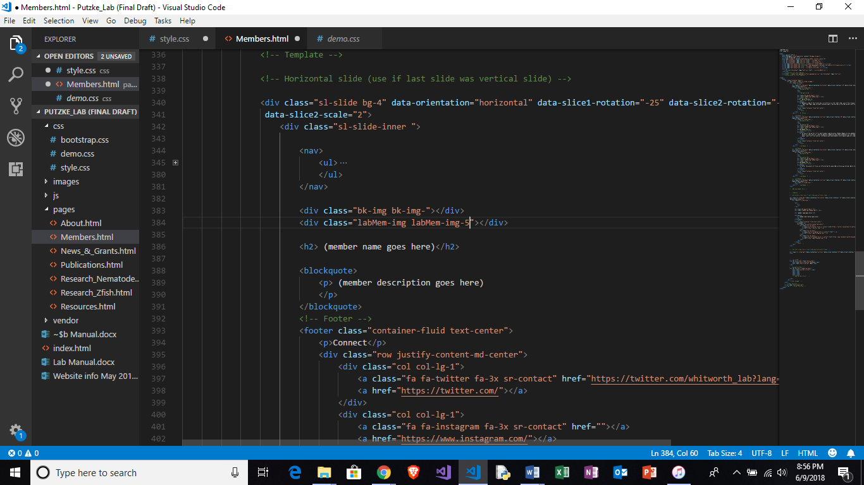

* **Similarly, a new background image can be set for your new slide by following almost identical steps as shown below**

